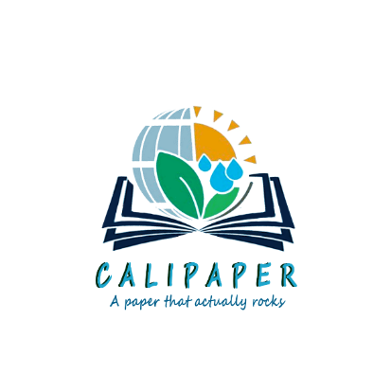

**Tatheer Zehra Mukhtar**

**DOW College of Biotechnology**

**Final year**

**INTRODUCTION**

*Every 2.5 seconds, a tree is cut down.*

Over 3 and a half tree is used by each living person every year to accommodate their need of paper and cardboard. Data shows that every year, about 4 to 8 billion trees are spoiled to produce paper products.

How about we shift the game of paper production in Pakistan?

Conventionally, the primary materials used in the papermaking process include cellulose fibers, chemical additives, and a lot of water. How about replacing the idea of tree with stones and absolutely no water?

*We present the idea of CALIPAPER – A paper that rocks.*

CALIPAPER is developed from the ground up to be better than wood-pulp paper: more durable, more sustainable, and infinitely smoother to write, scribble, doodle, or draw on. It is made from major percent responsibly recycled stone and contains no bleaches or acids.

For many years, recycling has been at the forefront of environmental activism. Greenwashing is prevalent across all industries. While it is wonderful that individuals and companies have grown environmentally conscious and are recycling many products, recycling is not a 'clean' process in and of itself, and is merely a temporary solution to the trash problem. Given that just a portion of all objects across all industries can be recycled, this situation is only going to get worse.

We must all work together to implement new technology as an alternative.

**PROBLEM**

**420,000,000 tones Annual output of cardboard and paper worldwide**

* Every person on Earth typically uses 2 pieces of paper every hour, or 420 million tons of paper annually. We are not yet a paperless civilization, it is anticipated that demand for paper would double in the upcoming years.
* Paper manufacturing has a negative impact on the environment due to deforestation, the consumption of massive quantities of energy and water, as well as air pollution and waste issues. Paper makes up around 26% of total garbage in landfills.
* A kilo of paper needs 2-3 times its weight in trees to produce. There would be no trees left if everyone used 200 kilograms of paper every year.
* A lot of water is required for paper manufacture. Depending on the mill, a single A4 sheet of paper requires between 2 and 13 liters of water. In Western countries, the pulp and paper sector is the single greatest industrial user of water.
* China, US, Japan are the top 3 countries that are producing paper. Pakistan doesn’t falls in the top 10 countries that produces paper. Despite the fact that paper is widely utilized, Pakistan cannot manufacture enough paper to fulfil demand. The cost of normal paper rises when it is exported.
* To break down wood pulp and bleach paper, hazardous chemicals such as chlorine and chlorine compounds are used. Boiler ash, effluents, sludge, and suspended particles are all byproducts of these harsh and dangerous chemicals.

Naturally, these byproducts have an environmental impact, especially when they are dumped into nearby water sources and soil. While the paper sector has accepted responsibility for its chemicals and pollution on occasion, the expenses of clearing up their mess are passed on to the consumer. Sulphur compounds and nitrogen oxides are also emitted into the atmosphere, causing respiratory problems such as chronic bronchitis.

* Regarding overall garbage in landfills, paper makes up around 26% of the total waste.
* Increasing population is leading to cut down of forests for fulfilling land and domestic needs. In future years, we will be in short of trees to fulfill our increasing paper demand.
* For every kg of paper produced, 1.15 kg of carbon emission is generated.

**Solutions**

*1 ton of calipaper can save up to 20 trees and 1600 gallon water.*

Calipaper is an environmentally friendly alternative to wood pulp paper that provides a better writing experience. Our objective is that your notebook will act as a springboard for you to do and create more ethically.

* calipaper is made without the use of any acid, bleach, or optical brighteners. It may be recycled into fresh stone paper (but only when separated and recycled at designated municipal amenity sites).
* calipaper have a smoother surface than most typical goods since it is not constructed from cellulose fibers, reducing the need for extra coating or lamination.
* Stone paper is a form of paper composed of 80% calcium carbonate (limestone) and 20% bio-polyethylene resin (HDPE). HDPE is employed as a binder in this example. As a result, limestone from existing limestone quarries is utilised as the raw material, which is then processed into a fine powder.
* Additionally, the stones utilised in this entire process are gathered as construction trash, resulting in a reduction in the amount of land rubbish produced by the construction sector.
* While ordinary paper employs several strengthening agents, the mineral content of our paper is held together by a non-toxic HDPE resin.
* Because Stone paper is naturally white, it does not require any further bleaching. Stone paper products keep their form over time due to their great density.
* Stone paper is waterproof, grease resistant, and washable due to its composition. The texture is akin to tissue paper.
* The items are disposed of and recycled as usual. The stone paper is converted back into calcium carbonate and then back into limestone.
* Using minerals, CaCO3 as alternative to pulp fiber and freshwater
* Manufacturing uses far less energy, which results in much less CO2 emissions.
* No streams are contaminated by toxic waste.
* It is more recyclable than conventional paper, hence the secret to a circular economy.

|  |  |  |  |  |  |  |  |
| --- | --- | --- | --- | --- | --- | --- | --- |
| ENVIRONMENTAL  COMPARISON  CHART | | | | | | | |
| Material | Production (MT) | Wood Use (MT)¹ | Trees Cut | Energy (BTU) | CO2 Equivalent (MT)4 | Water Consumption (Gallons) | Solid Waste  (MT) |
| 100% Virgin Paper | 1 | 2.7 | 20 | 19,315,100 | 1.5 | 15,6585 | 0.157 |
| 100% Recycled Paper | 1 | 0 | 0 | 17,934,920 | 1.4 | 5,8425 | 0.197 |
| calipaper | 1 | 0 | 0 | 2,968,563 | 0.6 | 0 | 0 |

Below are some statistics that show how calipaper is more environmentally safe than a traditional paper.

**Cost**

Our creative concept for CALIPAPER was born out of a desire to preserve natural resources for coming generations. To create this study, we conducted a massive literature review—which we are still working through—as well as several lab-scale experiments. However, we are unable to provide the ideal outcomes owing to a lack of funding and resources.

But we may create a significant change in the paper market of Pakistan if we work diligently, sincerely, and with the newest technological instruments and financial investments. If we are given enough chances and resources, we can offer premium-quality paper and associated goods and will undoubtedly gain our customers' trust.

A revolutionary product on the market, CALIPAPER is a cellulose-free paper produced primarily from waste materials. Our goal is to adopt a different style of thinking and heedlessly adopt current industry trends. We want to create a safer, cleaner world where people can live. The concept of CALIPAPER has the potential to significantly contribute to the protection of the environment and the eradication of pollution. It undoubtedly shows to be worthwhile of investment.

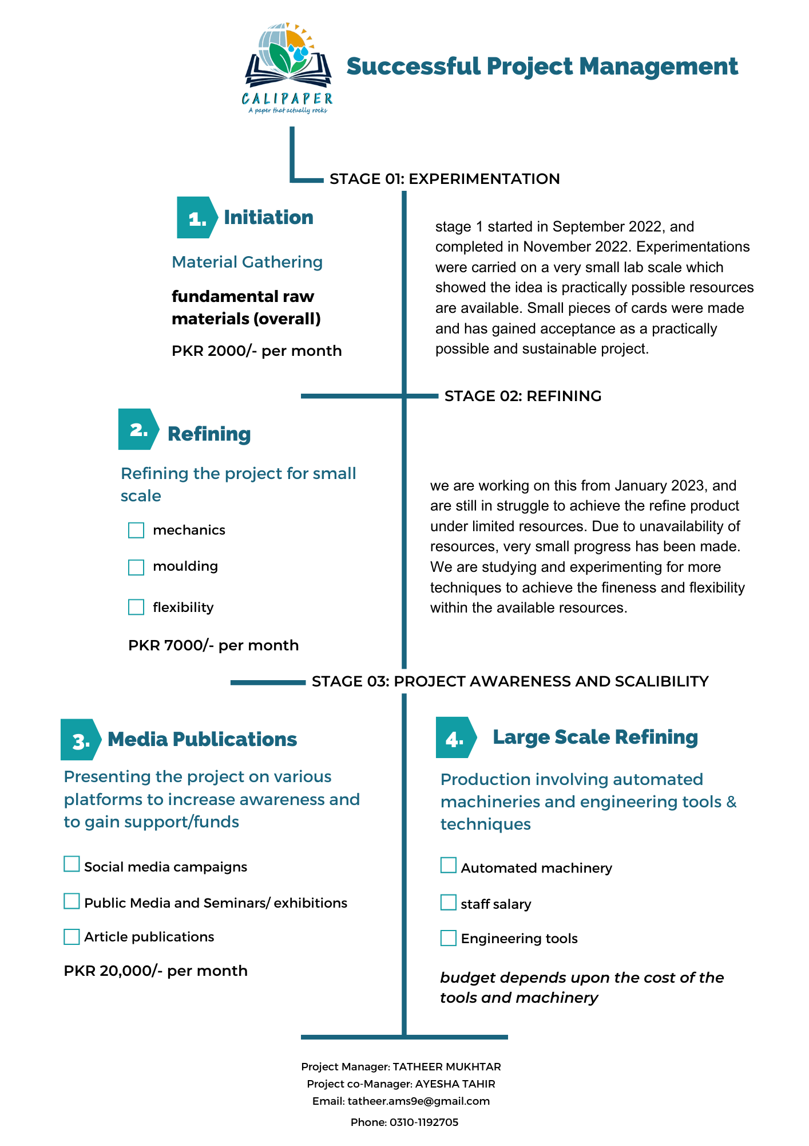

**EXECUTIVE SUMMARY:**

Just because paper has always been created from wood pulp does not mean that it always has to be. Function should always take precedence over form. As a result, we believe that the paper of the twenty-first century should be more durable and eco-friendly than ever.

Because we are in the moment. It ought to be better.

Bringing up the concept of paper that is water-proof, tear resistant, and stronger, so that now your content is more secure to any kind of liquid spills.

CALIPAPER is developed from the ground up to be better than wood-pulp paper: more durable, more sustainable, and infinitely smoother to write, scribble, doodle, or draw on. It is made from major percent responsibly recycled stone and contains no bleaches or acids.

We take dust and turn it into paper.

Calcium carbonate is combined with resin. Combine heat with pressure. And come up with something fresh.

A writing surface unbelievably smooth. Liquid impervious. Infinitely more powerful.

It's all made up of the construction waste.

Stone Paper is pretty self - explanatory like: paper manufactured without the use of cellulose fibers but rather using crushed stone. We can take a giant step forward protecting our world by using stone paper. It is prepared using 80% calcium carbonate (limestone). This indicates that no trees will be used in its manufacturing, and neither any bleach or water.

Additionally, the stones utilised in this entire process are gathered as construction trash, resulting in a reduction in the amount of land rubbish produced by the construction sector.