**BEETROOT WITH INNOVATION A MIRACLE FOR HYPERTENSION AND DIABATIES**

**RESEARCH PROPOSAL**

**SUPERVISOR DETAILS:**

* Yasmeen

(Lecturer)Marketing Department of IBHM

* Qualification

Institute / Degree Awarding University: M Phil (HRM) from PAF Kiet, M.Ed. (Education), from Jamshoro Sindh University, M.Com (Marketing) from Karachi University

* Email

[**yasmeen.khan@duhs.edu.pk**](mailto:yasmeen.khan@duhs.edu.pk)

**PROJECT MEMBERS:**

* Sana khalid(pharmacist)[ MBA-1 STUDENT DUHS IBHM][{sk.dr17@gmail.com](mailto:%7bsk.dr17@gmail.com)}
* Arifa Farooq(pharmacist)[ MBA-1 STUDENT DUHS IBHM] [{arifafarooq@gmail.com}](mailto:%7barifafarooq@gmail.com%7d)

**SDG GOAL FOLLOWED:**



**EXECUTIVE SUMMARY:**

Understanding consumer’s preferences in the development and marketing of *BEETROOT* syrup is crucial for developing its market while the growth of diabetes and hypertension is growing worldwide, dietary intake plays a remarkable role in the management of disease complications. Evidence suggests that beetroot has health-promoting potentials beetroot as the vegetable contains nitrates which dilates the blood vessels and is good for lowering blood pressure and also the phytochemicals which traps free radicals and Beets contain an antioxidant called alpha-lipoid acid. This compound may help lower glucose levels and increase insulin sensitivity. As we know that beetroot has a bitter taste so people instead of having many potential effects ignore that or avoid intake of that. The plan focus on that, we want to make people understand that it can be in that form which easy to intake hence, we have prepared formulation in syrup form [which is a clear liquid ] adding preservatives(ascorbic acid) and flavoring agents whose glycemic index is very low so it can be effective for diabetic patients as well, without any harm. Also there are no reported articles or evidences which shows the existence of syrup formulation in solution form because there are evidences of beetroot juices, powder form available in market. Our product formulation is also following number 3 goal of SDG (Sustainability Development Goals) out of 17 i.e. good health and wellbeing.

**ABSTRACT:**

The red beets are a great vegetable that attracts increasing interest in many research fields like medicine, pharmacy and food technology. Beta vulgaris used as nitrate dietary supplementation, a precursor of nitric oxide, which improves and cure the function of endothelial and provide protective and curative effects against hypertension and cardiovascular diseases. Our Aim was to develop the novel beta vulgaris solution for cardiac diseases, hypertension, hyperlipidemia, anemia inflammation, oxidative stress, cognition, endothelial function and demineralizing. Coarse powder of beet root with excipients were took for the formulation of solution, a variety of quality identification tests for solutions were analyzed i.e. appearance, sedimentation rate, size of particle determination, drug content, as per monograph USP and also determine its stability and therapeutic effect by analyzing numerous test methods associated with the quality and purity of solution. The main advantage of formulation of solution dosage form is to reduce patient compliances and give fast absorption then tablets. As a result, we have concluded that beta vulgaris solution meets the criteria laid in the monograph in term of variety of in-vitro QC methods. This formulation is cost effective and easy to administer and have longer stability and shelf life

Key Words: Suspension, cardiac diseases, Beta vulgaris, quality control

**INTRODUCTION**

Beetax V prevents cardiovascular diseases and other health related complications. Beetroot is main ingredient of Beetax-V. Beetroot is among the richest dietary nitrates sources which improve blood flow, heart health and the ability to exercise in heart diseases. Dietary nitrate dilates blood vessels to decrease blood pressure and may reduce overstimulation of the nervous system which leads to heart failure.

Beetroots are a rich in antioxidant, fiber, betaine, flavonoids, vitamins (vitamin B2, vitamin B12, vitamin C, and biotin) & minerals (zinc, magnesium, potassium and calcium, copper, folate) that mineralizing the human body and also helps protect cells, proteins and enzymes from environmental stress. Beetroot also contain unique bioactive compounds called betalains, which are emerging phytonutrients that have been shown to provide substantial curative and protective effects on human health as they are bioactive and completely safe.

NATURAL ENERGY BOOSTER: Studies have found that beetroot makes the muscles more fuel-efficient, thereby enhancing stamina. One such study involved men aged from 19 to 38, who cycled on exercise bikes. In taking about half a liter of beet juice a day enabled them to cycle 16 percent longer without getting exhausted.

NATURAL LIVER SUPPORT SUPPLEMENT: Your liver does the heavy work of cleaning your blood and “detoxing” your body. You can lighten its load with a daily serving of beets. Research shows that betaine, an amino acid found in beets, it can help prevent and reduce the accumulation of fat in the liver.

**SOLUTION TO THE PROBLEM:**

**METHODOLOGY:**

**Materials:** Take 20g of local red beet that previously washed and peeled material then cut into small pieces then dried it then reduce its size by gridding then pass from sieve no. 20 then pass from sieve no. 10 to make particle size 10-micron meter. The biomaterial was sterilized then stored in accordance with the procedure. All other reagents used herein were of analytical grade and buy from “Dae-Jung chemical Korea” and “Lab grade”.

**Preparation of Beetax-V (beta vulgaris) suspension**: coarse powder of beet root 4g /100ml, xanthan gum as suspending agent, invert sugar, as taste flavor, purified water q.s to 100ml.

**Testing:** Various quality control tests for suspension were performed like, appearance, sedimentation volume, degree of flocculation, re-dispersability, particle size determination, drug content, uniformity of mass, mass variation studies as per monograph USP. To study investigates the stability of beet root suspension in simulated in-home storage conditions at temperature ranging from (2-8oC) representing refrigerator condition. Samples from suspension were assayed and tested for related substance (degrades) using B.P pharmacopeia HPLC method. The study was performed in day zero, seven, fourteen, thirty and forty-five. The instrument employs column ® C8, 100 x 4.6 mm, 3.5 μm particle size. The mobile phase consisted of methanol, tetrabutylammonium hydroxide (40 %) and sodium orthophosphate buffer. We also performed microbial test against variety of micro-organism by culture test. We perform all this repeatedly every month since 3 months.

**OUR CORE COMPETENCY:**

* Our beetroot syrup has no sugar added and is therefore healthier than other syrups. People with diabetes can consume our syrup.
* Enthusiastically marketing efforts are made to ensure to raise awareness about uses of the product.
* We use recycled plastic bottles in different sizes and shapes with a simplicity and creativity. Thus it’s both environmentally friendly and aesthetic.

**OUR POINT OF DIFFERENTIATION:**

* Our syrup is innovative because there is no other syrup formulation available for beetroot
* Syrups are easy to consume
* It will be available in easy and air-tight child-friendly bottles
* We will target the people of every class of the Karachi first then overall Pakistan

**TARGET MARKET:**

* You hear almost in daily basis in business world that is **target market.** First we understand about what is target market?
* The people who are going to purchase your goods or services are your target market. By identifying your target market in advance, you can customize your offerings and make sure that your limited advertising funds are only going to those who will genuinely benefit from the products you're offering.
* **WHY THIS PRODUCT:**
* According to go through many research we came to this conclusion that Beetroot is good for heart disease and diabetics patients, But mostly or 76% people don’t like to eat beetroot but it is beneficial for people who are under in disease and also normal people who are going to be active in life because it’s may reduce weight also. So we decide to formulate the syrup of beet root and also we aware the patient to use the product.
* This product is usually **useful** for diabetes and heart patient. Phytochemical which are present in beet root help to control insulin sensitivity and blood sugar. According to INTERNATIONAL DIABETICS FEDERATION in 2022 ratio of diabetes in adult is 26.7% which are higher than in passing year. If we tell about heart disease so According to the most recent WHO statistics on the prevalence of heart attacks in Pakistan, 240,720 persons passed away in Pakistan in 2020 as a result of coronary heart disease. This syrup is useful for all of the ages. . Male and female both carry this syrup. Mostly primary target audience is women over 45. After menopause women’s can be suffer more health issue and risk for increase blood sugar and heart diseases. Some women experience in diabetes and rise in blood pressure during pregnancy so it is also useful for these women so pregnant women are also a secondary target audience.

**BRAND LOGO:**

**BRAND DISPLAY:**

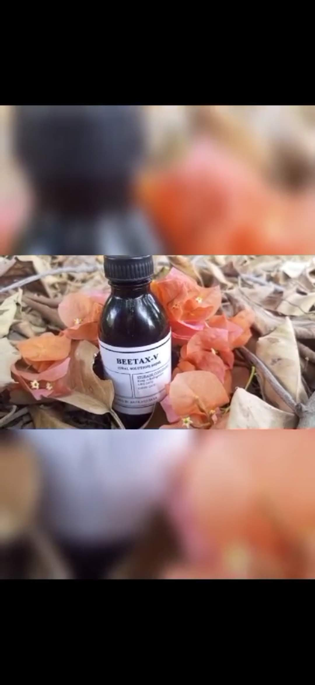

**INDICATION AND USES:**

* IT IS INDICATED FOR hypertension.
* It is for oral use.
* Not suitable for children below two years.
* Adult dose is 25ml a day.

**PRODUCT SHIPPER SIZE:**

We are preaparing 100 bottles four set of 100ml bottles.

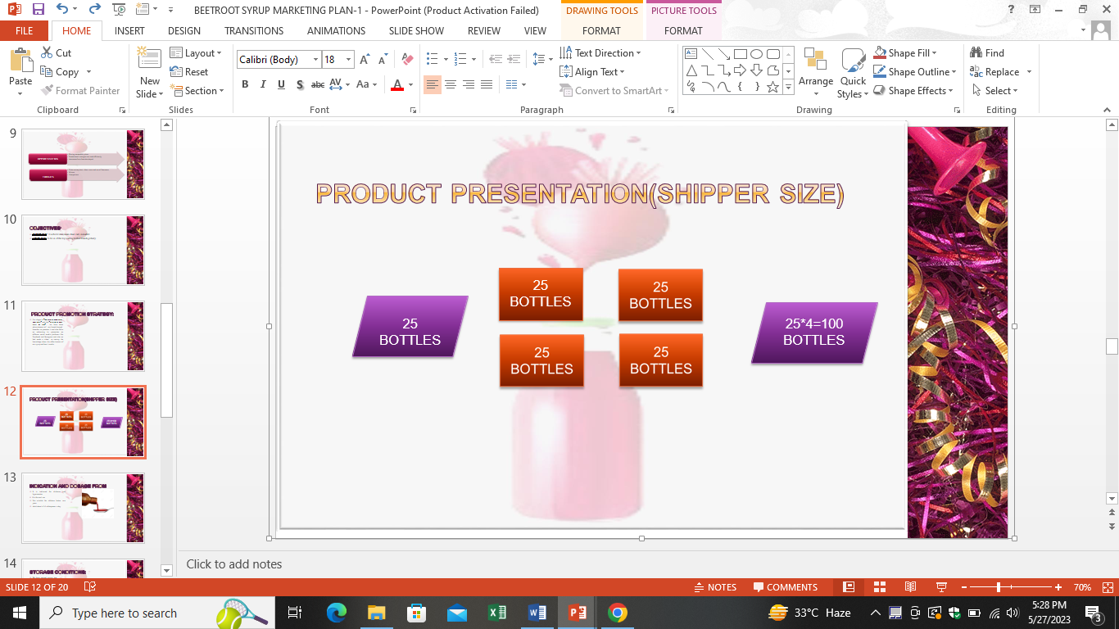

**PROMOTIONAL EXPENSE:**

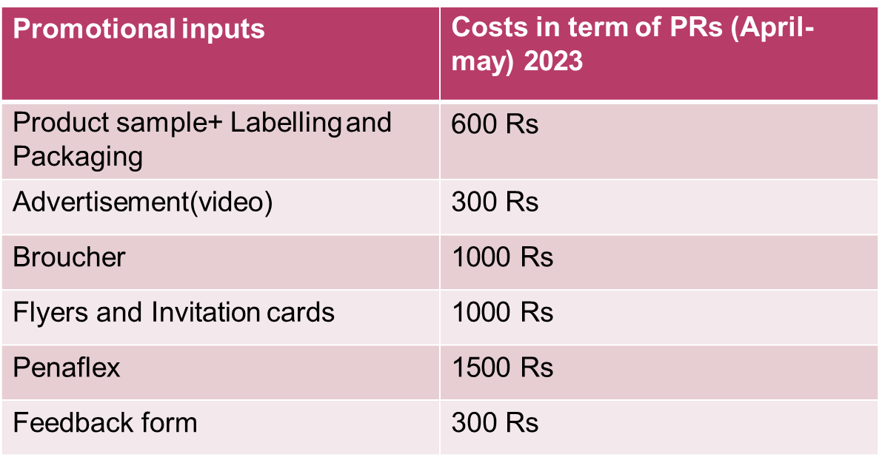

**STABILITY TESTS:**

***QUALITY CONTROL TEST:***

Sedimentation volume value of F is between the limit range that is 0 to 1. The higher sedimentation volume the better is the physical stability.

Re-dispersibility: suspension is easily re-dispersed

upon shaking.

***MICROBIAL TESTING:***

Beet root suspension also show antimicrobial activity against E.coli , B. subtilis, P. aeruginosa and E. aerogenes.

**RESULTS AND DISCUSSION:**

Our formulations clear all quality control tests and value comes under their limits**. pH value:** pH of suspension also important for stability of formulation and the stability of betanin depends directly on its pH, which ranges from 3 to 7 so we use buffer solution and check the pH that is 6.2 **Sedimentation volume** value of F is between the limit range that is 0 to 1. The higher sedimentation volume the better is the physical stability. **Re-dispersability**: suspension is easily re-dispersed upon shaking. And also show antimicrobial activity against E.coli , B. subtilis, P. aeruginosa and E. coli and E. aerogenes. Beetax-V suspensions table upon storage for 3 months after opening.

**CONCLUSION:**

* As a result, we have concluded that Beetax-Vsolution meets the criteria laid in the monograph in term of various in-vitro QC parameters like particle size determination, sedimentation volume, drug content, and its release, viscosity. However, drug release is more, physical stability reflecting better.
* Beta Vulgaris formulation is very effective to diabetic patients and also it has pronounced effects for cure cardiac diseases, hypertension, hyperlipidemia, anemia and demineralizing.
* This formulation is cost effective and easy to administer and have longer stability and shelf life. Beetax-V contain , No Additives, No Preservatives, No Artificial Colors, No Flavors, No Soy, No Fillers and No Gluten.
* Beetax-V suspension clear the phase I of formulation development. So in up-coming days we work on phase II, phase III. And phase IV and also work on formulation of other different dosage form of beet root and will also develop different strength Beetax-v.

**REFRENCES:**

* Kale, R., Sawate, A., Kshirsagar, R., Patil, B. and Mane, R., 2018. Studies on evaluation of physical and chemical composition of beetroot (Beta vulgaris L.). *Int J Clin Sci*, *6*(2), pp.2977-79.
* [International Journal of Sport Nutrition and Exercise Metabolism](https://www.researchgate.net/journal/1543-2742_International_Journal_of_Sport_Nutrition_and_Exercise_Metabolism) 22(6):470-478 · December 2012
* Eggebeen, J., Kim-Shapiro, D.B., Haykowsky, M., Morgan, T.M., Basu, S., Brubaker, P., Rejeski, J. and Kitzman, D.W., 2016. One week of daily dosing with beetroot juice improves submaximal endurance and blood pressure in older patients with heart failure and preserved ejection fraction. *JACC: Heart Failure*, *4*(6), pp.428-437.
* Lidder, S. and Webb, A.J., 2013. Vascular effects of dietary nitrate (as found in green leafy vegetables and beetroot) via the nitrate‐nitrite‐nitric oxide pathway. *British journal of clinical pharmacology*, *75*(3), pp.677-696.
* Nyakayiru, J., Jonvik, K.L., Trommelen, J., Pinckaers, P.J., Senden, J.M., Van Loon, L.J. and Verdijk, L.B., 2017. Beetroot juice supplementation improves high-intensity intermittent type exercise performance in trained soccer players. *Nutrients*, *9*(3), p.314.
* Krantz, C., Monier, M. and Wahlström, B., 1980. Absorption, excretion, metabolism and cardiovascular effects of beetroot extract in the rat. *Food and cosmetics toxicology*, *18*(4), pp.363-366.