**PROPOSAL**

UN SDGs 3 GOOD HEALTH AND WELL BEING

*VALUE ADDED JAGGERY PRODUCTS*

By Dr Ghazala Farooq,Dr radia Ali,Dr Kanza Ishaq

MBA

IBHM,DUHS.

Supervisor:Yasmeen





**Table of Contents**

**1.Executive Summary**

**2.Abstract**

**3.Introduction**

**4.Vision and Mission**

**5.Project background**

**6.Solution to the problem**

**7.Goals and deliverables**

**8.Budget line for small business**

**9.Conclusion**

**Executive Summary**

Nutraceutical, functional or fortified food not only supplements the diet but also assists in developing immunity and preventing diseases. Jaggery (non- centrifugal sugar), made from sugarcane juice, is one of them. It is known to mankind for the last 3000 years and is an essential part of the diet in the rural part of many countries. Jaggery is recognized as a nutraceutical due to the presence of a variety of essential aminoacids, antioxidants, phenolics, minerals like calcium, phosphorus, iron, and vitamins. Jaggery has a better natural source and nutrients for health benefits and could be used as a healthier dietary substitute to white sugar. The nutraceutical value of jaggery can be enhanced with value addition and fortifi- cation of medicinally important herbs and spices. This would not only enhance the quality of nutritive jaggery but will also offer value-added products with exciting flavors for daily use sweeteners with several nutritional health benefits.

**Abstract**

The noncentrifugal sugar which is prepared from sugarcane juice is called as Jaggery and is known by different name in the world such as Panela, Kokuto, and Muscovado. The [nutrient value](https://www.sciencedirect.com/topics/food-science/nutritive-value) of jaggery is increased while preparing with different methods from sugarcane juice. The [micronutrients](https://www.sciencedirect.com/topics/food-science/micronutrient) which are present in Jaggery have many nutritional and medicinal aspects such as its anticarcinogenic and antitoxic activity. Jaggery has proved itself better when compared with white sugar. Jaggery is known to produce heat and give instant energy to a human body. Sugar and sweet consumption have been popular throughout the world, increasing trend of per capita [sugar consumption](https://www.sciencedirect.com/topics/nursing-and-health-professions/sugar-intake) assumes significance in view of the high tendency for individuals to develop insulin resistance, [abdominal adiposity](https://www.sciencedirect.com/topics/nursing-and-health-professions/abdominal-obesity), and [hepatic steatosis](https://www.sciencedirect.com/topics/nursing-and-health-professions/fatty-liver), and the increasing chronic disease such as [type 2 diabetes](https://www.sciencedirect.com/topics/nursing-and-health-professions/non-insulin-dependent-diabetes-mellitus) and cardiovascular diseases. Multiple prevention strategies could be adopted to decrease the white sugar consumption from various stakeholders (government, industry, and consumers) by different methods such as increasing taxation on sugar-sweetened beverages and increasing promotion for the consumption of jaggery and related products.

Rao, G. P., & Singh, P. (2022). Value addition and fortification in non-centrifugal sugar (jaggery): A potential source of functional and nutraceutical foods. *Sugar Tech*, *24*(2), 387-396.

**Introduction**

The healthcare market is constantly evolving and progressing because of researches based to improve quality of life. As part of the healthcare industry, we focus on improving health and wellbeing of people. This involves multitudes of smaller changes rather than big change.

It is multitasked process which begins with educating people about making right choice of their food intake. Our role to play in this development would be to contribute to the health and well-being of the people by providing organic addition in their everyday life. Balanced food is thought to be a healthier diet that will benefit human health in addition to the usual healthy diet requirements. It is also known as functional food, which is food that makes a clear claim of health benefits, as well as a claim of boosting the immune system. Besides, malnutri- tion and undernutrition are also of major concerns around the globe, especially in developing countries. Jaggery is a healthy non-centrifugal sugar (NCS) that is being used across many Asian/African countries and Colombia. Nowadays, different value-added food products made of jaggery are being used globally as part of daily cuisine, drinks, and desserts. ‘Gur’ is the Indian word for jaggery and is mentioned as a sweetener in Ayurvedic medicines for over 3000 years. However, the name jaggery is derived from the Portuguese word ‘*jagara’* that means coarse brown sugar. Indian Refined white sugar consists of sucrose, while jaggery consists of minerals and vitamins along with glucose, fructose (invert sugars), and sucrose. The jaggery consists of mineral con- tent (calcium, phosphorous, magnesium, potassium, iron, zinc, copper, and vitamins (folic acid, B-complex, etc). Jaggery not only provides energy but also helps to avoid rheumatic diseases, bile disorders, weakness, muscle, nerve, and blood vessel relaxation, regulates blood pressure and decreases water accumulation, and raises hemoglobin levels to prevent anemia. According to Ayurveda, jaggery is found to be useful in the treatment of throat and lung infections.

**Disadvantages of sugar.**

Sugar intake is a major public health problem that has gained popu- larity in recent years among people of all ages. Dietary sugar in excess raises the risk of metabolic conditions including obesity and diabetes as well as cardiovascular disorders. In many countries,

different epidemiological studies and trials have associated a high consumption of sugar-sweetened beverages (one of the main dietary sugar sources) with weight gain, poor dental health, cancer, metabolic syndrome, heart disease and type 2 diabetes mellitus .Mechanisms of some major health problems caused by consuming reﬁned sugar are shown in Figure 1.

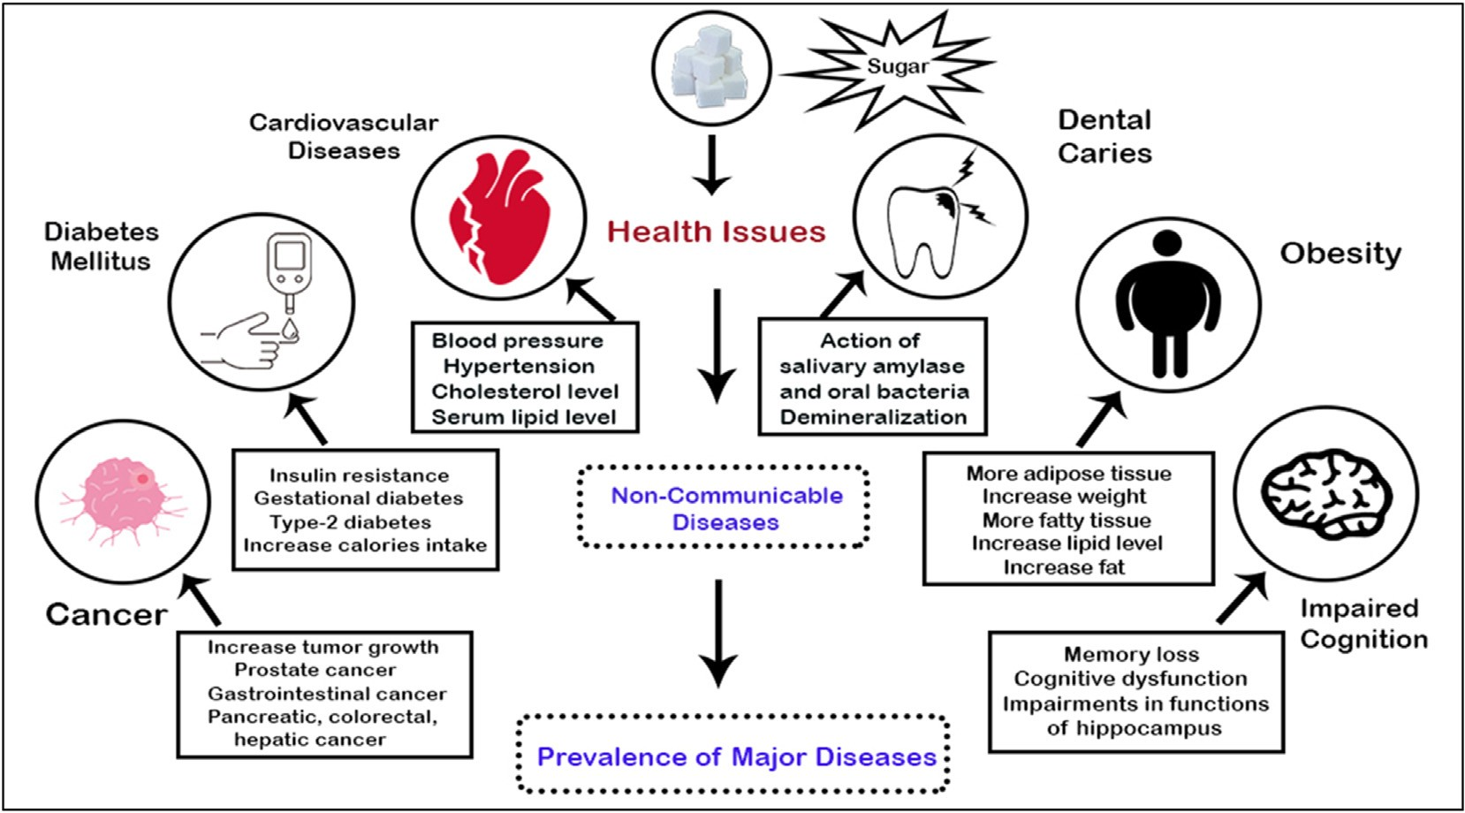

Health issues with sugar

VISION STATEMENT

‘To contribute to the health and well being of people by providing natural organic addition in their everyday life.’

MISSION STATEMENT

Our mission is to improve the health of those we serve by educating them to make correct choice about their food.

Also ensuring to abide by **UN SDGs No 3 GOOD HEALTH AND WELL BEING.**

We have identified a niche in the market where we believe we can provide products to the customers.

Position Strategy

We have positioned jaggery as an healthier alternative to sugar and artificial sweeteners

**Project Background**

Pakistan is a poorly developed country. It stands at 166 among 195 countries in terms of equlity and accessibility to healthcare. The budget allocation to health is given below <https://dailytimes.com.pk/assets/uploads/2021/06/22/a.png>

Health spending per capita

According to global economy health spending per capita, the average value for Pakistan during period 2000 to 2019 was 27.08 U.S. dollars with a minimum of 13.59 U.S. dollars in 2001 and a maximum of 42.87 U.S. dollars in 2018. The latest value from 2019 is 39.5 U.S. dollars. For comparison, the world average in 2019 based on 180 countries is 1159.89 U.S. dollars.

Major Disease occurence

Disease occurrence in different parts of Pakistan shows high prevalence of communicable and non communicable diseases.Some informational figures are given below.

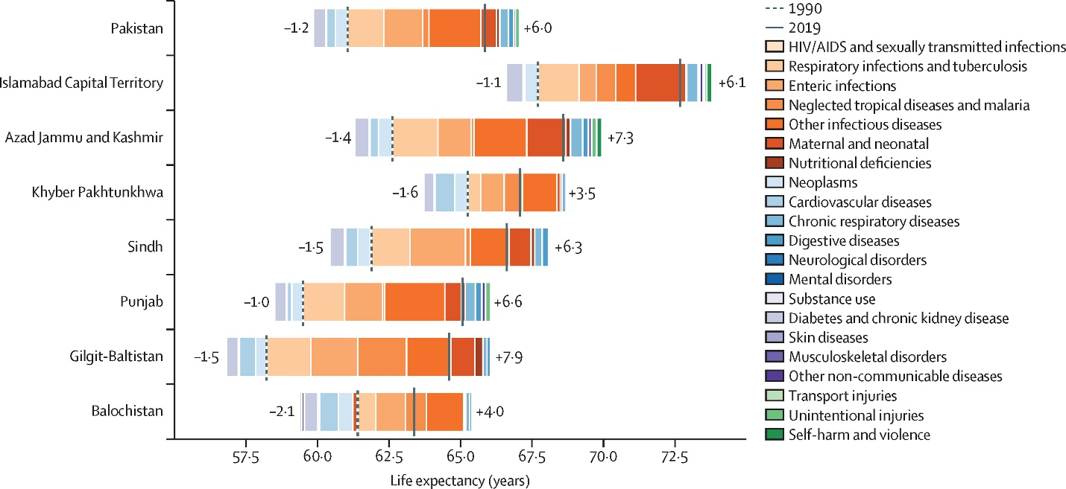 https://www.thelancet.com/cms/attachment/24b6c6b4-6392-4d1b-bebd-c235fc5c1833/gr1.jpg

This show high occurrence of respiratory, cardiovascular and many infectious diseases.

Also the expected rate of deaths estimated from these diseases is high.

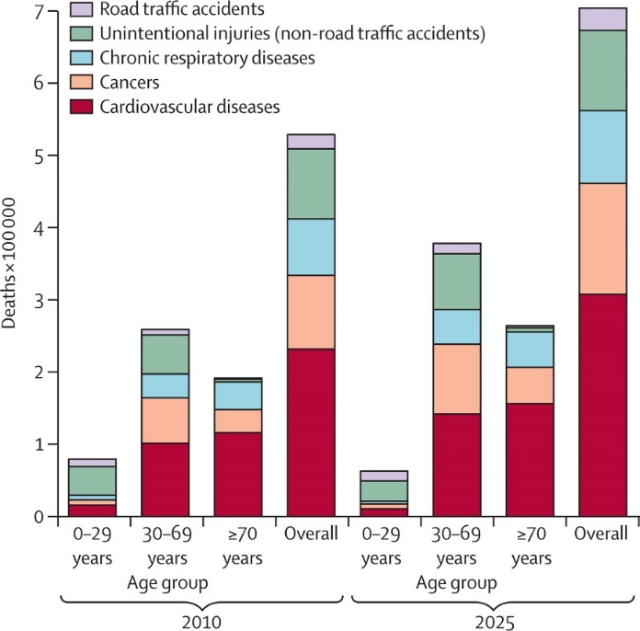 <https://www.thelancet.com/cms/attachment/e2add8e6-e6f5-487d-8288-8cf01077ffbd/gr1_lrg.jpg>

These data indicates that Pakistan is unable to meet target due to multiple factors. At a basic level, if we can endure to improve the health of people by providing better substitutes in food and thereby reducing ailments. This will in turn lessen the burden on health sector by reduced patients flow at all levels of health care.

**SOLUTION TO THE PROBLEM**

**Goals**

The primary goal is to introduce organic food in the form of Jaggery, blended and fortified with natural beneficial spices.

*Target customers* for the product are health-conscious individuals who are looking for healthier alternatives to refined sugar. This includes people who are conscious about their sugar intake, fitness enthusiasts, and people who are looking for organic and natural products. We also target children who are sweet lovers but could not differentiate between the choice of products that they are consuming.

*Collaborators* :

We would be collaborating with healthcare practitioners, fitness influencers and nutritionists who can promote the health benefits of jiggery and some value addition to jiggery.

*Competitiors:*

The primary competitors for this product are other natural sweeteners like honey, maple syrup, and stevia.

*Content:*

The trend towards healthier lifestyles along with consuming natural products provides an excellent opportunity for the marketing of jaggery.

SWOT ANALYSIS

*Strength*:

Our strength lies in the basic concept of improving the health of people. We focus on products which helps to prevent the occurrence of many diseases. This helps in combating increase patients turnout of various diseases. There are numerous studies done on benefits of jaggery and other ingredients that shows the importance of these products.

*Oppurtunity*:

Public health is an ever growing area Oppurtunitiy lies in the growing concept of people toward taking care of their health with limited artificial food substitutes.

*Weakness*:

We are a new company with an existing market for sugary products. Lack of vast research hinders the exact percentage of people consuming sugary items and those who are inclined towards natural foods.

*Threats:*

Threat lies in the mal intention of existing brands.There is also high chance of people not accepting the urgency of using such products.

**Deliverables**

Benefits of Jaggery

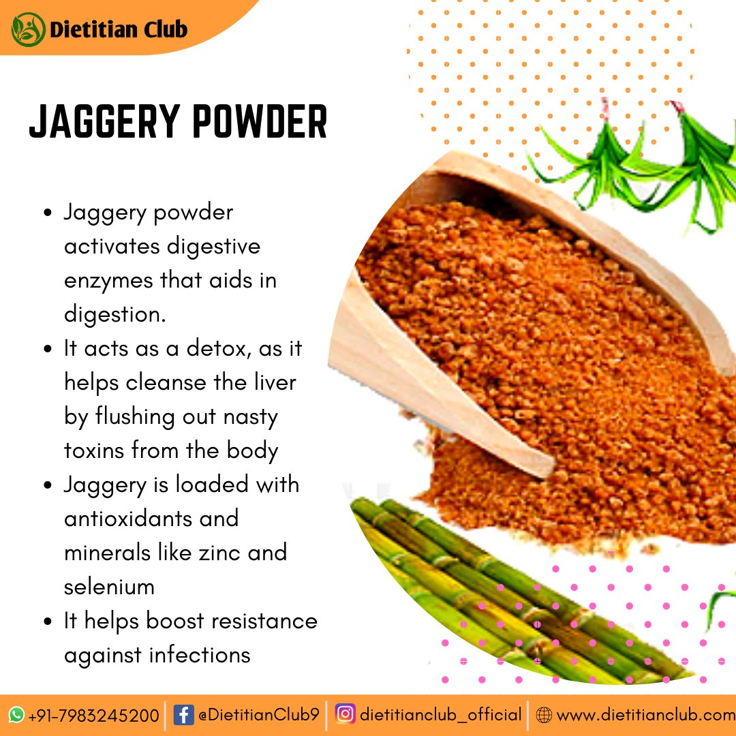

Although jaggery is itself a nutritious sweetener, it blending with other healthy spices gives benefits to the product manifold. Benefits includes antioxidant, anti-inflammatory, improved immune system.

1.Jaggery and cinnamom powder.

2.jaggery with ginger.

3.Jaggery with honey .

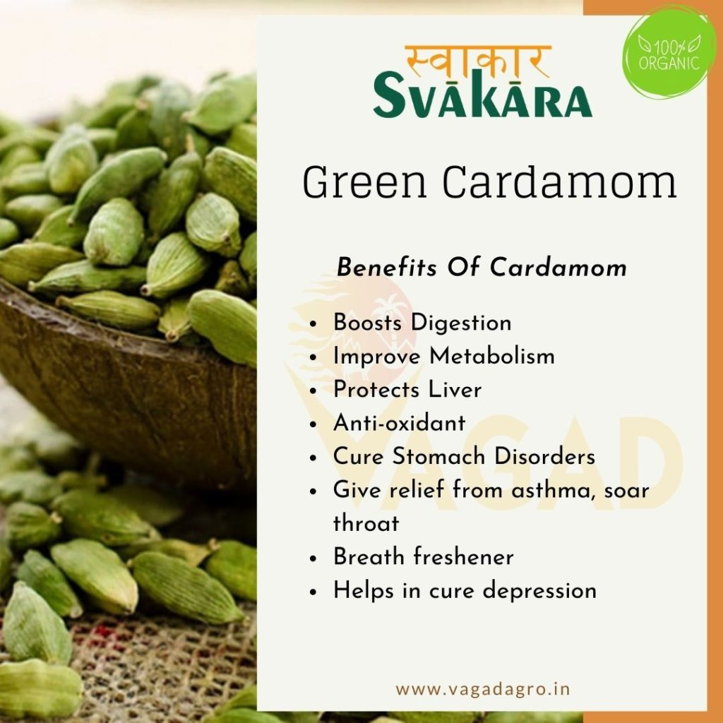

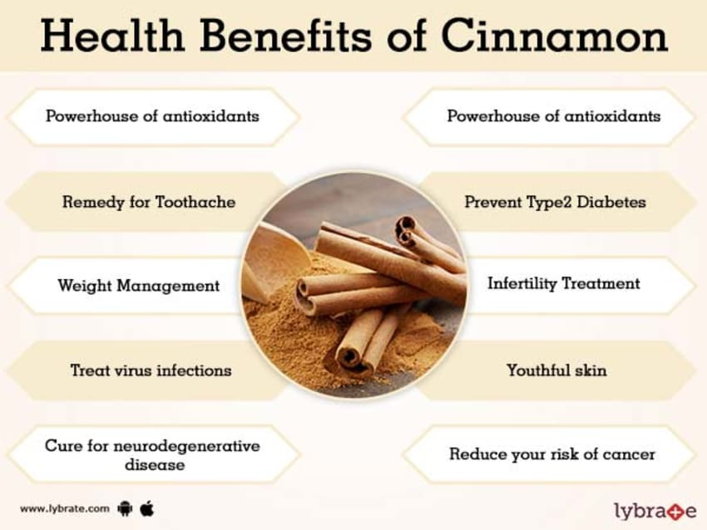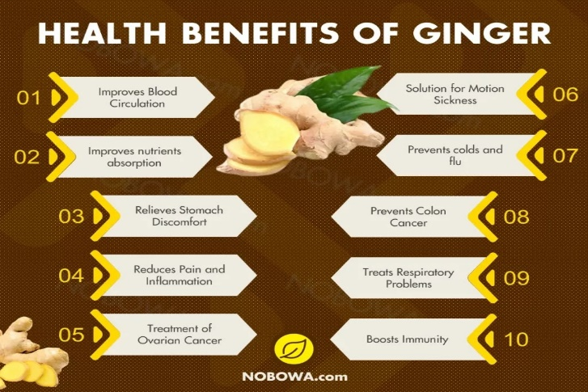

Products available:

1.Baked items(different kinds of cake),

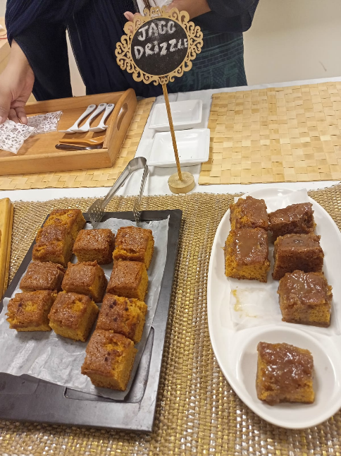

2.Jaggery candy(with value addition of ginger and honey),



3.Jaggery Spread (with value addition of cinnamom and cardamom.

**BUDGET LINE FOR SMALL BUSINESS**

1.Research and Development

a)market research : 15,000PKR

b)recipe development and testing:20,000PKR

c)packaging and branding design:20,000PKR

2.Production Setup

a)small scale production facility setup:50,000PKR

b)equipment and machinery:35,000PKR

c)quality control system:15,000PKR

d)Ingredients and supplies:10,000PKR

3.Production and Operations

a)Labour cost:20,000PKR

b)energy and utility expenses:10,000PKR

c)packaging materials:15,000PKR

4.Distribution and Logistics

a)transportation and delivery cost:10,000PKR

b)packaging and labelling compliance:5,000PKR

5.Contigency funds:10,000PKR

6.Legal and administrative fee:5,000PKR

**Total Budget:** 240,000PKR

**CONCLUSION**

Therefore, we conclude that based on the data of prevailing non communicable diseases and low healthcare infrastructure, importance should be given to modify lifestyle of people by helping them to make better and healthier choices. And jaggery based value added products are one of the healthy options.

References

Kumar, A., & Singh, S. (2020). The benefit of Indian jaggery over sugar on human health. In *Dietary sugar, salt and fat in human health* (pp. 347-359).

Academic Press. Rao, G. P., & Singh, P. (2022). Value addition and fortification in non-centrifugal sugar (jaggery): A potential source of functional and nutraceutical foods. *Sugar Tech*, *24*(2), 387-396.

Arshad, S., Rehman, T., Saif, S., Rajoka, M. S. R., Ranjha, M. M. A. N., Hassoun, A., ... & Aadil, R. M. (2022). Replacement of refined sugar by natural sweeteners: focus on potential health benefits. *Heliyon*, e10

<https://www.thelancet.com/cms/attachment/24b6c6b4-6392-4d1b-bebd-c235fc5c1833/gr1.jpg> <https://www.thelancet.com/cms/attachment/e2add8e6-e6f5-487d-8288-8cf01077ffbd/gr1_lrg.jpg>

<https://dailytimes.com.pk/assets/uploads/2021/06/22/a.png>