**DEVELOPMENT OF BIOSAFE STAIN FOR SDS-PAGE GELS**

Dow College of Biotechnology, Dow University of Health Sciences, Karachi-Pakistan

1. **INTRODUCTION**

Among all the gel electrophoresis techniques, sodium dodecyl sulfate-polyacrylamide gel electrophoresis (SDS-PAGE) is most commonly and widely used. It serves as both, qualitative and quantitative method and has profound application in the field of diagnostics, forensics and molecular studies. The method is basically used to study the homogeneity, purity, activity and quantity of biological macromolecules like proteins in a sample. The proteins to be analyzed are separated in gel on the basis of their molecular weight or mass to charge ratio in the presence of electric field. After electrophoresis, these separated proteins are visualized by staining with Coomassie brilliant blue (CBB) dye. The staining and destaining of gels require extensive use of hazardous chemicals i.e., methanol and acetic acid. Long term exposure to these chemicals can have deleterious effects on human health and poses threat to environment as well. Chronic exposure to these chemicals can cause nausea, dizziness, headache, vision problems, and even cancer. In the current study an eco-friendly stain “Biosafe Stain” have been developed. The biosafe stain showed equally sensitive staining compared to conventional staining method. Also, gels can be destained with water and does not require use of methanol and acetic acid. Also, the cost of the locally developed stain is far less than other imported staining solutions.

1. **PROBLEM TO BE SOLVED:**

Electrophoretic gels are commonly used in research and diagnostics and require organic solvent based staining and destaining solutions comprising of methanol and acetic acid. These are hazardous chemicals, their extensive use and long term exposure poses risk on health and environment. Therefore, there is need to replace the solvent based staining and destaining procedure for SDS-PAGE electrophoresis with environmentally friendly and cost-effective solutions providing similar sensitivity of staining.

1. **THE IDEA / SOLUTION**

To develop water based Biosafe staining solution for SDS-PAGE gels that can be subsequently destained with water. Staining and destaining with minimal solvent is the key benefit of above-mentioned idea. In this context, preliminary studies have already been performed at our lab where “Biosafe Stain” showed comparable staining sensitivity to conventional method as shown in figure below.

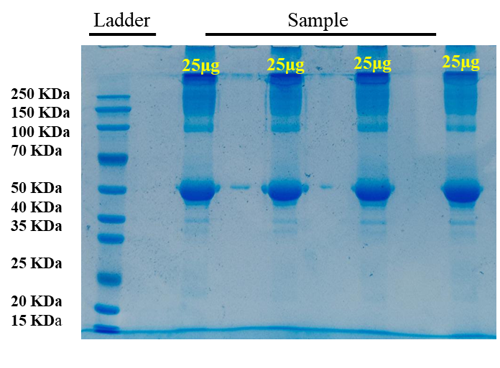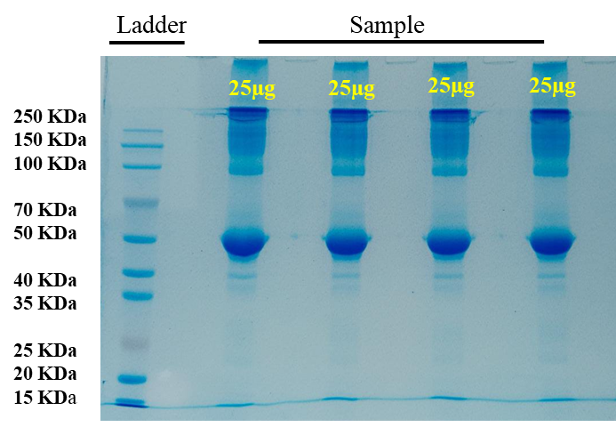

**Comparison of SDS-PAGE gels staining with (Left) Standard Method (Right) Biosafe Stain developed at Dow College of Biotechnology, Dow University of Health Sciences.**

1. **COST / SCHEDULE**

Experimental studies are in progress in order to further refine the product and method, and also its applicability to other types of protein based electrophoresis methods. For this, total cost 500,000 PKR is required. It includes all the expenses like raw materials (consumable and chemicals), product refining and prototyping, testing validation and, printing and packaging. The final product is expected to be available for consumers by December, 2023.

1. **EXECUTIVE SUMMARY**

Gel electrophoresis is most widely used technique in research for qualitative and quantitative analysis of biological molecules such as DNA, RNA and Proteins. It separates them in gel mainly according to their mass to charge ratio, molecular weight or isoelectric point. SDS-PAGE requires staining with Coomassie brilliant blue dye for visualization of proteins. Coomassie blue staining solution is prepared in methanol and acetic acid and subsequent destaining require considerable use of these chemicals. Short- or long-term exposure to methanol and acetic acid poses risk on human health, and when released into water affects environment, land and aquatic organisms. In this study, a biosafe stain has been developed that does not require use of hazardous chemicals for destaining. It showed comparable results to standard staining method and the cost is also much affordable compared to imported stains. Further experimental studies are in process to prove biosafe stain stability and wide applicability.

1. **TEAM**

Dr. Humera Waheed (DCoB)

Dr. Faraz Moin (KU)

Zahida Azhar (DCoB)

Nida Khan (DCoB)