**Development of *Drosophila melanogaster* Based Assay System for Screening of Carcinogenic Pollutants**

1. **Introduction**

Pollution is the presence of harmful substances in the environment, in higher than usual concentrations resulting in low quality of the environment [1]. Pakistan ranks as the 4th most polluted country around the globe [2]. The consequences of air, land and water pollution have left profound impacts on the physical, ecological and biological aspects of the country’s environment. Physical impacts include significant damage to infrastructure and heritage sites owing to corrosive contaminants present in acid rain [3]. Moreover, deforestation practices leading to land degradation give rise to physical pollutants, which cause extreme turbidity in receiving waters. [4]. Another grave impact on ecology is the destruction of local flora and fauna, loss of habitat, and rapid extinction of species [5].

The biological consequences are profound, with lasting impacts on the quality of human life. Life expectancy in Pakistan has lowered by 4.3 years for average citizen [2], owing to diseases like COPD (chronic obstructive pulmonary disorder) [6], heart diseases and lung cancer. Pollutants like particulate matter suspended in air, certain metal oxides, and organic compounds possess carcinogenic potential and have been linked to various types of cancers [7,8].

1. **Problem**

In today's rapidly advancing world, pollution has become a major concern. According to European Environment Agency (EEA), exposure to air pollution, second-hand smoke, radon, ultraviolet radiation, asbestos, certain chemicals and other pollutants are responsible for over 10% of all cancer cases in Europe [9]. Amongst these pollutants, certain substances have been identified as carcinogens, namely polycyclic aromatic hydrocarbons (PAHs), heavy metals (lead, arsenic), volatile organic compounds (benzene, formaldehyde) and persistent organic pollutants (polychlorinated biphenyls). Several studies suggested that pollution is also associated with increased risk of mortality for several types of cancer, including breast, liver, and pancreatic cancer [9,10].

To device any preventive measures, screening of chemical pollutants is absolutely necessary. Therefore, several screening methods using animal models have been devised to empirically demonstrate carcinogenic/oncogenic potential of the chemical pollutants. These assay systems includes; Ames mutagen assay [11,12], Comet Assay [13], Heteroduplexes analysis using high-performance liquid chromatography (HPLC), Mouse Lymphoma TK assay and Single-strand conformation polymorphism (SSCP) by electrophoresis. Nevertheless, all these assays have some limitations and shortcomings in terms of their execution, technical intricacies and precision and/or accuracy of the results [12,13,14,15,16]. In addition to these tests, a wing spot assay has also been developed in *Drosophila melanogaster* (fruit fly) for the detection of these chemical pollutants having carcinogenic potential [17] but not without limitations as it is based on the single trait observation. This results in many of the pollutants being misclassified for their oncogenic potential.

**3. How We Will Solve the Problem**

Existing repertoire of carcinogenic detection systems retains several disadvantages including wing spot assay developed in *D.melanogaster* because of the observational limitation to the single trait. Data from the earlier studies in our laboratory showed that oncogenic compounds affect multiple morphological and developmental traits. This indicates the possibility of development of improved and/or novel carcinogenic detection system in *D.melanogaster* by incorporating multiple morphological characteristics concomitantly. In this study it is aimed to develop a carcinogenic detection system encompassing variations in the multiple traits of the fruit fly. This in turn will improve the accuracy and precision for the detection of carcinogenic compounds and/or pollutants under *in vivo* condition.

**Methodology**

Methodology of the proposed project is shown in **Annexure 1.** Briefly, 50 eggs of *D. melanogaster* will be placed in different concentrations (**Table 1**) of EMS, titanium dioxide, acrylamide, ethanol, coffee, lead acetate, cumene, benzene and bisphenol-A in 10 replicates each making a total sample size of 14500 eggs. The compounds were selected on the basis of IARC list of chemicals which have grouped over 1042 chemicals on the basis of their carcinogenic potential. All progeny flies will be collected and stored in 70% ethanol for further assessment. Multiple observations will be made, by the stereomicroscopy and if needed scanning electron microscopy, for the exposed parents and developed progeny in terms of morphological changes in the shape, color and texture of eyes, thoracic bristles, size of legs, wing shape and wing venation. In addition, the flies will be subjected to histological investigations to monitor degeneration in brain and alteration in the thoracic musculature. The existence of warts on wings, eyes, head, thorax, halters and legs will be counted and aligned with the different concentrations of the compounds under investigation. To detect the presence of exposed mutagens and its metabolites in the fly blood, the hemolymph will be extracted and subjected to Thin Layer chromatography on Silica TLC plates and High-Performance Liquid Chromatography using C4 RP-HPLC column (250×4.6 mm). Based on the variation of traits comparative scale will be developed using both positive (EMS) and negative control (Cornmeal media). Finally, variations in the morphological and anatomical traits will be plotted against the exposed concentrations of compounds.

**Table 1. Concentrations of Different Compounds Used in the Experimental Sets**

|  |  |  |  |  |  |
| --- | --- | --- | --- | --- | --- |
| **Category** | **Medium** | **Mutagen** | **Conc.#1** | **Conc.#2** | **Conc.#3** |
| Negative Control | Standard Cornmeal | ---- | ---- | ---- | ---- |
| Positive Control | Standard Cornmeal | EMS | 5mM | 15mM | 25mM |
| Test 1  (Group I) | Standard Cornmeal | Benzene | 2% | 6% | 10% |
| Test 2  (Group I) | Standard Cornmeal | Ethanol | 4% | 8% | 12% |
| Test 3  (Group IIA) | Standard Cornmeal | Lead acetate | 100 ppm | 200ppm | 300ppm |
| Test 4  (Group IIA) | Standard Cornmeal | DDT | 7µg/mL | 14µg/mL | 21µg/mL |
| Test 5  (Group IIB) | Standard Cornmeal | TiO2 | 7µg/mL | 14µg/mL | 21µg/mL |
| Test 6  (Group IIB) | Standard Cornmeal | Cumene | 0.5mM | 1.0mM | 1.5mM |
| Test 7  (Group III) | Standard Cornmeal | Coffee | 0.5% | 1% | 2% |
| Test 8  (Group III) | Standard Cornmeal | Bisphenol-A | 2mM | 4mM | 6mM |

As a proof of principle, pilot studies have been conducted at Dow Fly Research Lab and Stock Center, DCOB to show developmental (**Annexure 2**), morphological (**Annexure 3**) and cellular (**Annexure 4**) changes from the exposure provided by different oncogenic compounds.

**4. Cost/ Schedule**

Detail of chemicals, consumables and equipment in succeeding table.

|  |  |  |
| --- | --- | --- |
| **S. No.** | **Chemicals/Consumables** | **Amount (PKR)** |
| 1. | Cornmeal | 30,000 |
| 2. | Dextrose | 20,000 |
| 3. | Sucrose | 20,000 |
| 4. | Methyl 4-hydroxybenzoate (NIPAGIN) | 30,000 |
| 5. | Dimethyl Sulfoxide (DMSO) | 20,000 |
| 6. | Technical Agar | 20,000 |
| 7. | Chemicals | 200,000 |
| 8. | Histology | 40,000 |
| 9. | Scanning Electron Microscopy (SEM) | 40,000 |
| 10. | C18 RP-HPLC Column | 80,000 |
| **Total** | | **500,000** |

**Equipment**

Major equipment required for the study is highlighted as following:

* Fly Incubator X 3 (available at Dow Fly Research Lab and Stock Center, DCOB)
* Fly Vials X 1000 (available at Dow Fly Research Lab and Stock Center, DCOB)
* Centrifuges (available at Dow Fly Research Lab and Stock Center, DCOB)
* Automatic Tissue Grinder (available at Dow Fly Research Lab and Stock Center, DCOB)
* Stereomicroscopes (Leica and Nikon) with Camera (available at Dow Fly Research Lab and Stock Center, DCOB)

**Gantt chart**

|  |  |  |  |  |  |  |  |  |  |  |  |  |
| --- | --- | --- | --- | --- | --- | --- | --- | --- | --- | --- | --- | --- |
| **Tasks/Months** | 1 | 2 | 3 | 4 | 5 | 6 | 7 | 8 | 9 | 10 | 11 | 12 |
| Consistent Exposure Breeding |  |  |  |  |  |  |  |  |  |  |  |  |
| Morphological Investigations |  |  |  |  |  |  |  |  |  |  |  |  |
| Anatomical Histological Investigations |  |  |  |  |  |  |  |  |  |  |  |  |
| Biochemical Investigations |  |  |  |  |  |  |  |  |  |  |  |  |
| Statistical Analysis and Scaling |  |  |  |  |  |  |  |  |  |  |  |  |
| Report Writing and Publication |  |  |  |  |  |  |  |  |  |  |  |  |

**5. Executive Summary**

Pollutants in our environment have been shown to possess oncogenic/carcinogenic properties [18]. Experimental evidence indicates a significant link between the incidence of cancer in humans with exposure to pollutants, drugs and other industrial/chemical products [19,20]. Therefore, it is of prime importance that an efficient screening method of mutagenic/oncogenic agents is devised to explore the biosafety of compounds. Existing systems retain several disadvantages, including wing spot assay developed in *D.melanogaster* [21]whereas prior studies in our laboratory indicate notable effects on other morphological and anatomical traits. Hence, an *in vivo* system involving investigation on different aspects of *D*.*melanogaster* including pupariation, fecundity, cellular profile, and morphological defects has been developed. Extramural grant will be sought to increase the span of testing for further validation with more concentration gradient and nature of compounds. Further potential remains to be explored in the devised assay system including histological, biochemical and functional investigations to increase the efficiency in the detection and further classification of known and possible pollutant carcinogens.

**Annexure 1**

C:\Users\user\OneDrive\Desktop\hadi methodology.tif

**Annexure 1. Principle of the Study.**  Flow diagram is schematically showing the methodology employed in the study.

**Annexure 2**

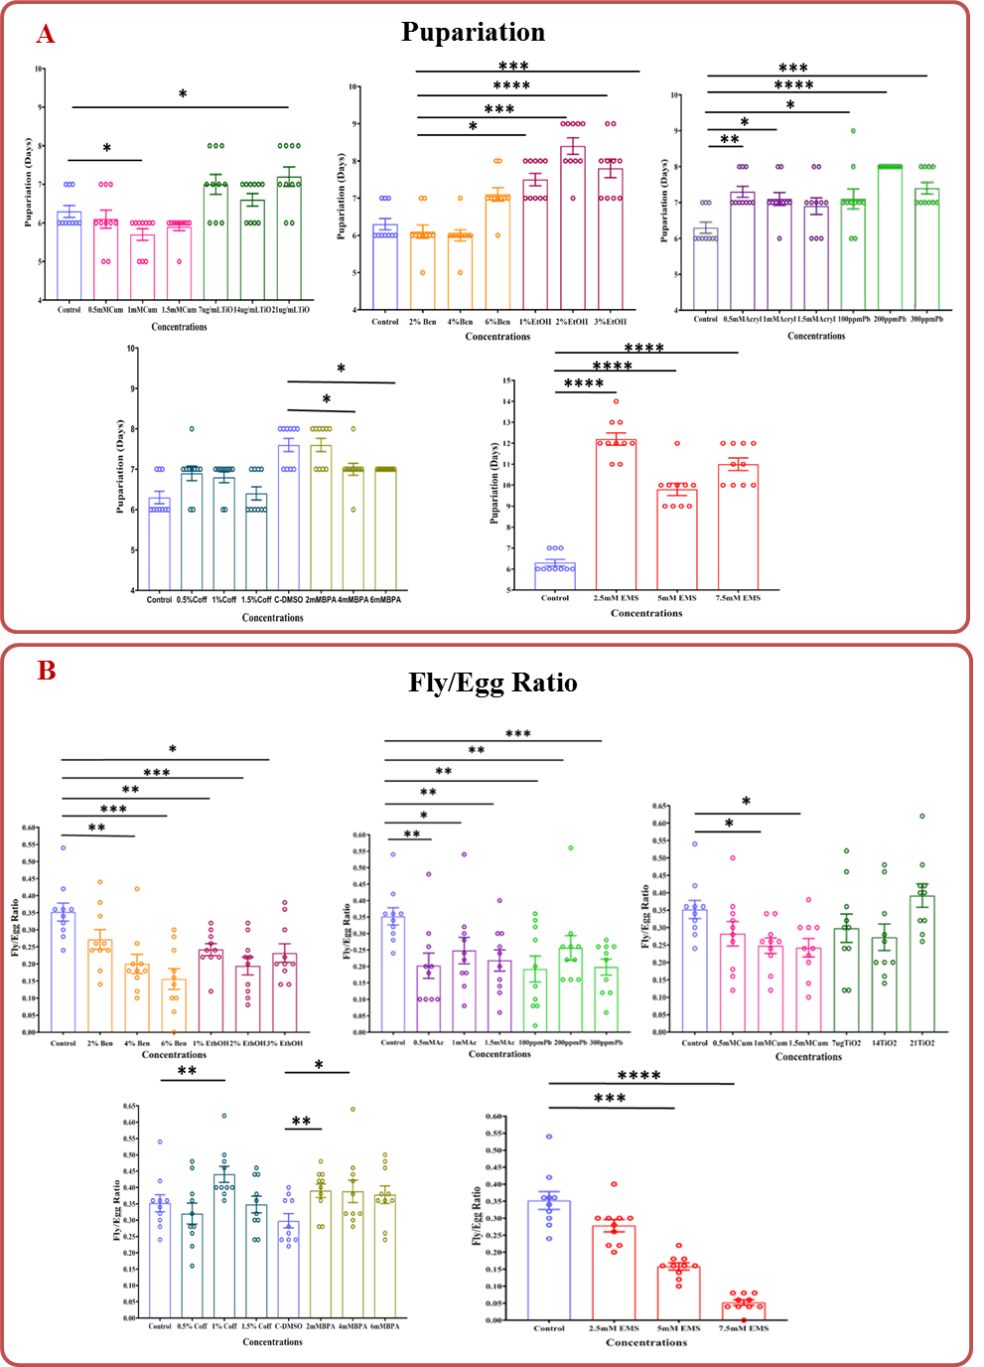

**Annexure 2. Effects of Carcinogen on Development of *Drosophila melanogaster*.** Histograms show the effect of different concentrations of carcinogens; as labelled; on pupariation (**A**) and fly to egg ratio **(B**). Height of the bar represents mean value whereas error bar represents standard error of mean. Statistical significance is denoted by **“**\***”**.

**Annexure 3**

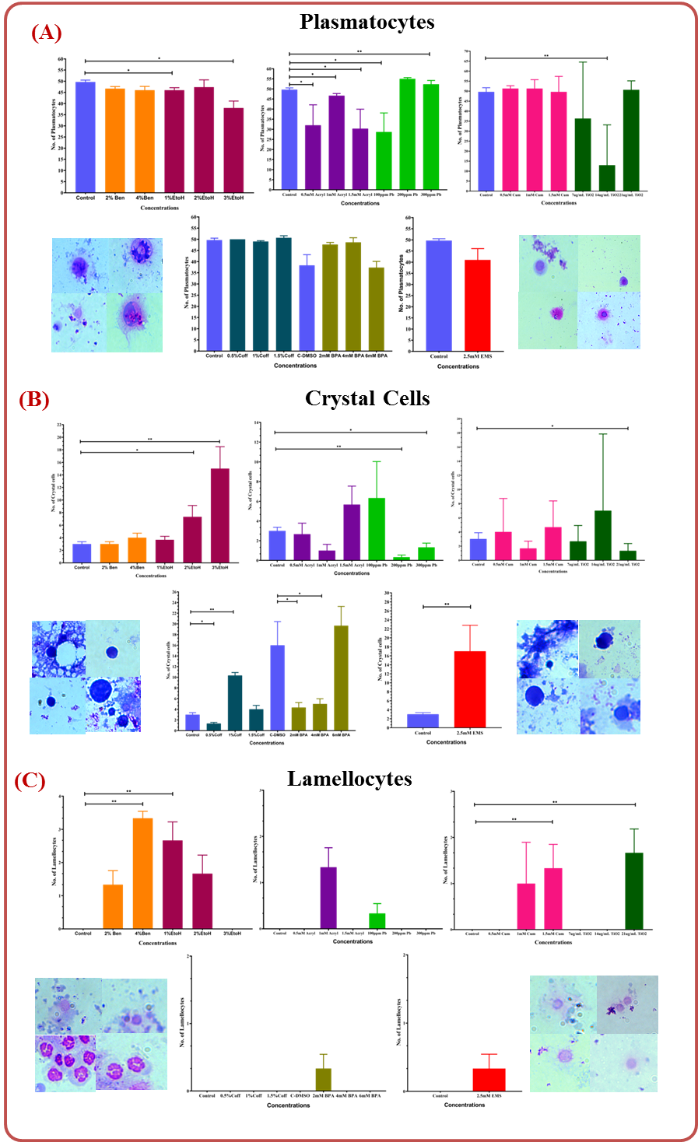

**Annexure 3. Blood Cellular Profile of Consistent Exposure in *Drosophila melanogaster*.** The count is shown for (A) Plasmatocytes, (B) Crystal Cells and (C) lamellocytes. 100X micrographs of typical morphology of cells labeled are shown. Height of the bar represents mean value whereas error bar represents standard error of mean. Statistical significance is denoted by **“**\***”**.

**Annexure 4**

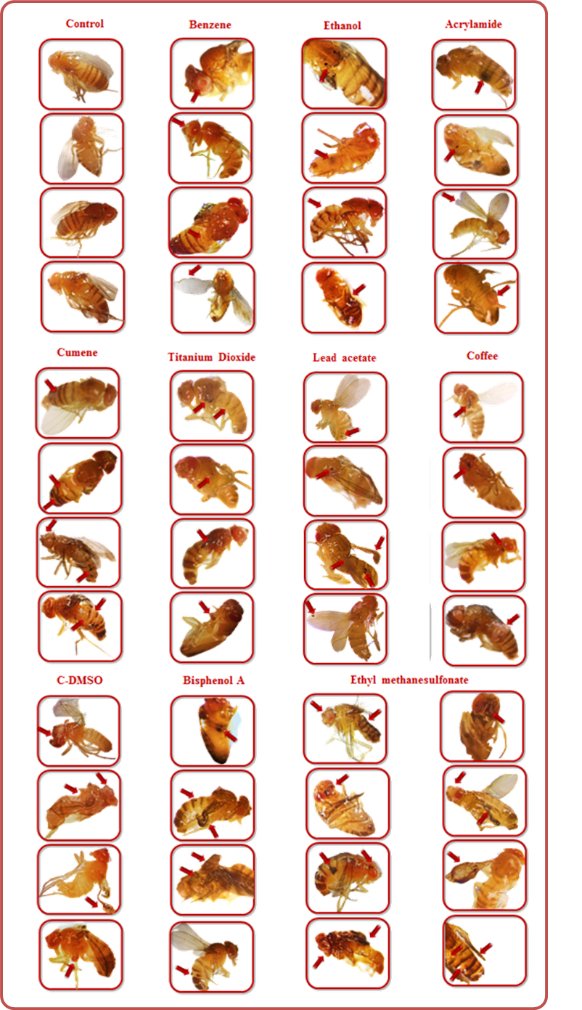

**Annexure 4. Stereomicroscopy of Defected Flies.** The panel shows morphological defects induced by exposure to different carcinogens, where the defected regions are represented by red arrows for better visibility.

**Annexure 5 : References**

1. Manisalidis I, Stavropoulou E, Stavropoulos A, Bezirtzoglou E. Environmental and health impacts of air pollution: a review. Frontiers in public health. 2020:14.
2. www.aqli.epic.uchicago.edu/country-spotlight/pakistan/
3. Spezzano P. Mapping the susceptibility of UNESCO World Cultural Heritage sites in Europe to ambient (outdoor) air pollution. Science of The Total Environment. 2021 Feb 1;754:142345.
4. Amarnath G, Pani P, Alahacoon N, Chockalingam J, Mondal S, Matheswaran K, Sikka A, Rao KV, Smakhtin V. Current Directions in Water Scarcity Research.
5. www.endangered.org/a-roundup-of-endangered-species-impacted-by-ocean-pollution.
6. Khorrami Z, Pourkhosravani M, Rezapour M, Etemad K, Taghavi-Shahri SM, Künzli N, Amini H, Khanjani N. Multiple air pollutant exposure and lung cancer in Tehran, Iran. Scientific Reports. 2021 Apr 29;11(1):9239.
7. www.eea.europa.eu/highlights/pollution-and-cancer.
8. www.aacr.org/patients-caregivers/progress-against-cancer/air-pollution-associated-cancer/
9. Khorrami Z, Pourkhosravani M, Eslahi M, Rezapour M, Akbari ME, Amini H, Taghavi-Shahri SM, Künzli N, Etemad K, Khanjani N. Multiple air pollutants exposure and leukaemia incidence in Tehran, Iran from 2010 to 2016: a retrospective cohort study. BMJ open. 2022 Jun 1;12(6):e060562.
10. Asian Development Bank [ADB]. Islamic Republic of Pakistan Country Environment Analysis.
11. McCann J, Choi E, Yamasaki E, Ames BN. Detection of carcinogens as mutagens in the Salmonella/microsome test: assay of 300 chemicals. Proceedings of the National Academy of Sciences. 1975 Dec;72(12):5135-9.
12. Zeiger E. Identification of rodent carcinogens and noncarcinogens using genetic toxicity tests: premises, promises, and performance. Regulatory Toxicology and Pharmacology. 1998 Oct 1;28(2):85-95.
13. Costa, Solange (2014). *Encyclopedia of Toxicology || Comet Assay. , (), 1020–1023.*
14. Aaron CS, Bolcsfoldi G, Glatt HR, Moore M, Nishi Y, Stankowski L, Theiss J, Thompson E. Mammalian cell gene mutation assays working group report. Mutation Research/Environmental Mutagenesis and Related Subjects. 1994 Jun 1;312(3):235-9.
15. Panigrahi S, Velraj P, Rao TS. Functional microbial diversity in contaminated environment and application in bioremediation. InMicrobial diversity in the genomic era 2019 Jan 1 (pp. 359-385). Academic press.
16. Orita M, Suzuki Y, Sekiya T, Hayashi K. Rapid and sensitive detection of point mutations and DNA polymorphisms using the polymerase chain reaction. Genomics. 1989 Nov 1;5(4):874-9.
17. Graf U, Würgler FE, Katz AJ, Frei H, Juon H, Hall CB, Kale PG. Somatic mutation and recombination test in *Drosophila melanogaster.* Environmental mutagenesis. 1984;6(2):153-88.
18. www.cancer.gov/about-cancer/causes-prevention/risk/substances
19. Griffiths AJ, Miller JH, Suzuki DT, Lewontin RC, Gelbart WM. Relation between mutagens and carcinogens. InAn Introduction to Genetic Analysis. 7th edition 2000. WH Freeman.
20. Huff J. Chemicals and cancer in humans: first evidence in experimental animals. Environmental health perspectives. 1993 Apr;100:201-10.
21. Verheyen GR, Deun KV, Miert SV. Testing the mutagenicity potential of chemicals. J. Genet. Genome Res. 2017;4.