**EMPRESS MARKET VERSION II**

***An innovative Idea by: Ms. Surraya Shams-Faculty DIMT DUHS***

**Background:**

According to the most recent official figures, Karachi's population has risen by 1.6 million to over 17.6 million people which other non-governmental parties claim to be 20 million approx. Among these population the 2014 statistics showed 70% of Karachi's people were poor. If we increase the ratio after the COVID pandemic where thousands of industries and factories bare the significant loss the ratio will significantly high. As per World Bank's defined “POOR” in economic terms (ignoring all of its social, political, and cultural causes and repercussions) as those earning less than $2.15 per day which is now equal to this date is 650 PKR. Recently, a media science project reveals a monthly salary of Rs 35,000 to Rs 40,000 was insufficient to cover family costs, and they had to borrow money from creditors or relatives to cover their expenses, particularly during religious festivals and other rites. Obviously to meet the ends, the guardian of the families seeks the option of daily wages. One of the most promising daily wages source in poor class is mobile fruit and vegetables carts. These carts require no security, no land, and no tax to run their trading.

**Problem:**

A high percentage of interior population are living in Karachi and because of their illiteracy, they are either begging or seeking these micro trade options. One mobile cart can easily be purchased from 13 thousand (See Images below) which is a very minimum investment to run a small trade business. Mobile fruit and vegetable carts can visibly be seen among the road side of Karachi. In result, extreme road blocks and monopoly of prices can visibly be observed. Moreover, KMC is putting a blind eye as many “Kathey” are running aside with it.

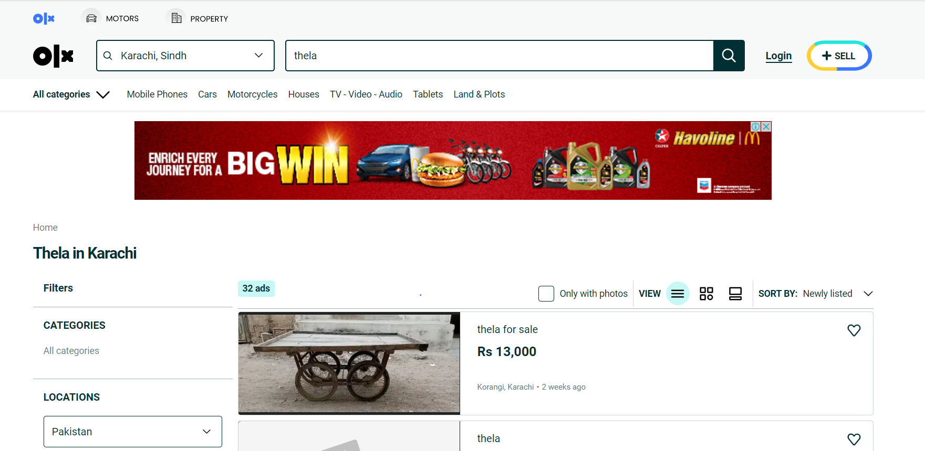

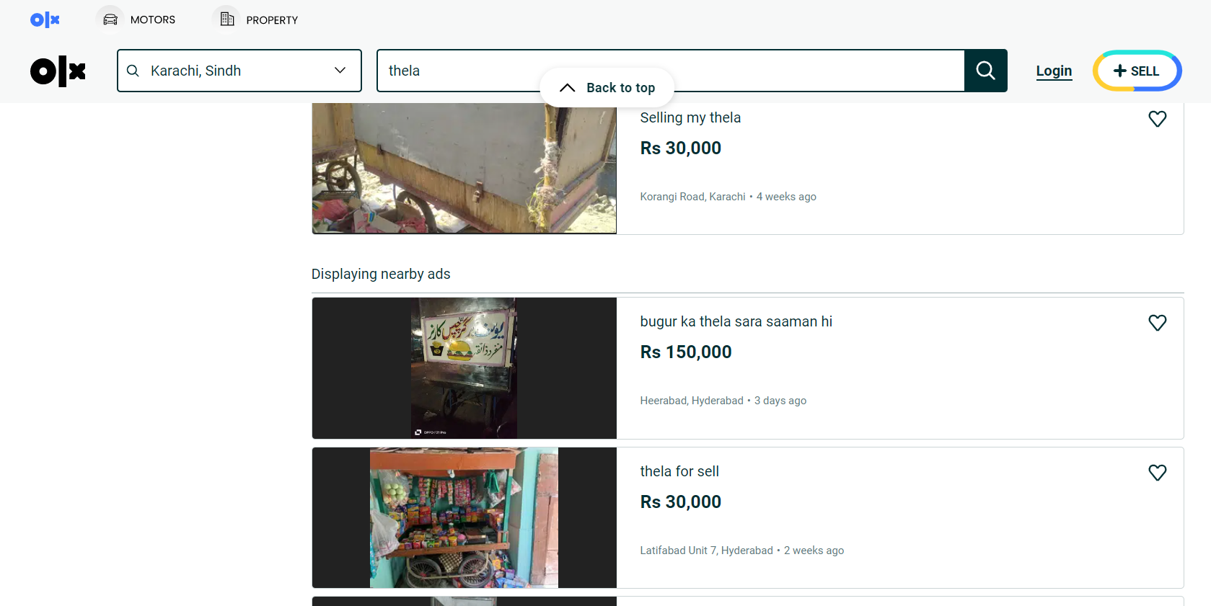

**Solution:**

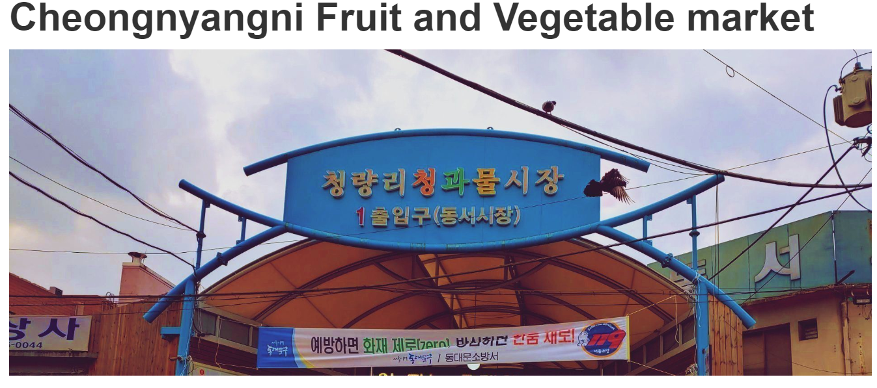Empress Market a living heritage of Karachi has a history of 150 years old. Its infrastructure was designed to home of hundreds of shops where from the food to pets can easily be traded. This market still hold its beauty and uniqueness not only in trade but also a center of various services. What I contemplate here is to use abandoned parks and spaces around Karachi and built a mini market where fruits and vegetables can be purchased easily. Many countries has been utilizing the abounded spaces where they provide quality and fresh fruits, vegetables, meat and other food items in clean, tidy and sterilized environment (See Images below). Moreover, it will reduce the traffic blocks where citizens stops at road side to collect the fruits and vegetables.

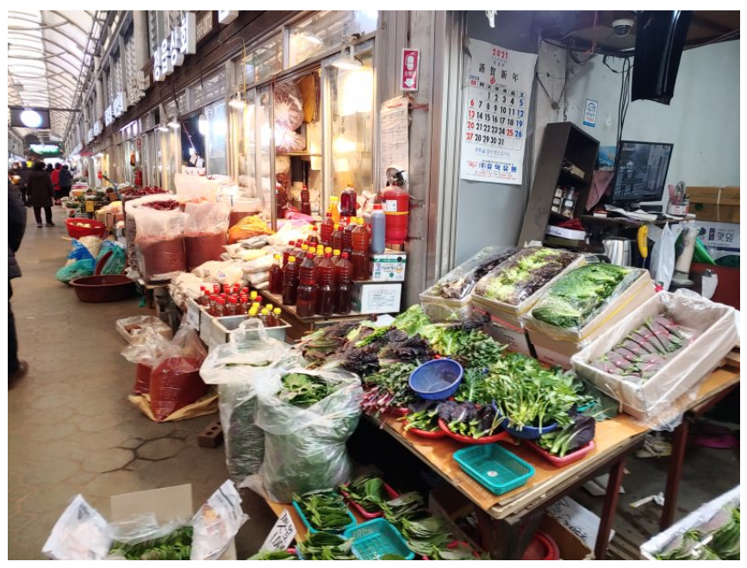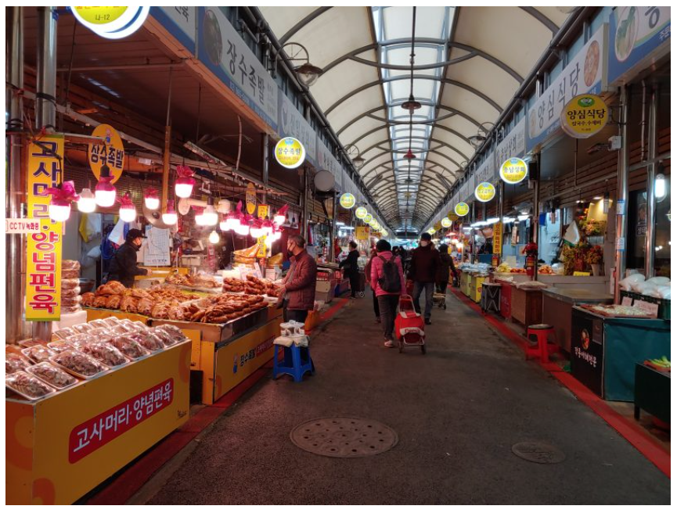

**Executive Summary:**

Karachi is Pakistan number one tax payable city and last year 50% tax was collected from Karachi only. If we utilize our forgotten and neglected resources and turn them into a micro trade centers, Insha’Allah Karachi will again rise strongly in economically more than previously.

**Resources:**

***Newspapers and Media Reports***