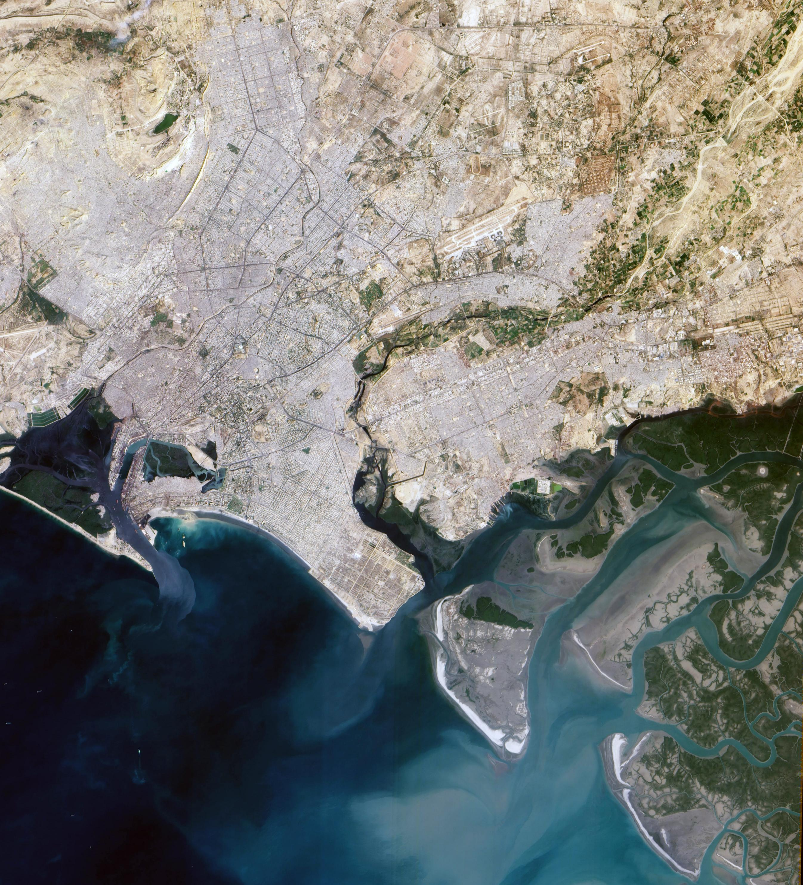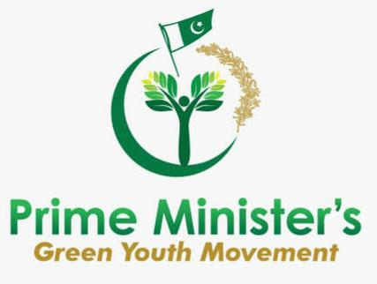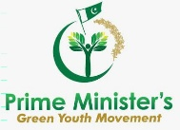

**By: Syeda Saba Atif**

**“THE CLEAN AND GREEN KARACHI”**

**Prime Minister’s program of Green Youth movement club at D.U.H.S**

**Introduction**:

وہ جذبہ جس سےحسین لگ رہا تھا آئینہ  
کہاں گئ کہ میری دلکشی کو موت آئ۔  
اختر جواد   
  
The feeling due to which the mirror was beautiful,  
Has been lost somewhere, my beauty is dead.  
Akhtar Jawad.

When writers die, they become books. When cities die, they become ruins; Moenjo Daro, Taxila, and many others all tell a tale about their culture, their inhabitants and their rulers. Climate change, utter  neglect by the rulers and the ruled, corruption, misgoverance and lack of political will are all killing Karachi - once the City of Lights! The Quaid must be turning in his grave with grief!

The environment is in us, not outside of us. The trees are our lungs, the rivers are bloodstream. We are all interconnected. What we do to the environment, ultimately we do it to ourselves.

The colours green and blue are more than just shades. Green, the colour of life, renewal, nature and energy, is associated with meanings of growth, harmony, freshness, and safety.    
It is quite unfortunate that the city’s breath taking beauty suffers at the hands of its own people. A trip to any tourist site in Karachi will make you marvel at the natural beauty but at the same time it will leave you embarrassed. Why? The ubiquitous litter and the unsightly debris you see lying around at these places doesn’t appear out of thin air.

**Problem**

It is about time we **change our mind set as a nation**. Protecting environment is not a choice, it’s a necessity. For a clean and green Karachi, we need to play our part.

**Working**

According to a study Karachi has lost a huge amount of its green cover, through land grabbing, ill planned road routes deforestation/ (mangroves) and retains only 7%, whereas every large city needs 25% of green cover to provide clean lungs to the city.

It has become a common sight on roads that people toss the litter right out of the vehicles they are travelling in, especially public transport. We have become immune to this sight and don’t do anything about it. The footpaths are littered with fruit wastes, banana peels, cigarette butts, chips wrappers, and juices packs. Now with the onset of winters, orange peels and peanut shells have joined the over increasing garbage on our side roads.

To change this mindset and bring about a behavioral change in public to achieve a sustainable and safe environment in Pakistan, the present government recently launched an app for people volunteering to make a change in the cities by initiating certain activities that can be reported online along with details and pictures. This Pakistan Clean Green Index (CGPI) is a composite index of five pillars of Clean Green Pakistan Movement i.e. safe drinking water, total sanitation, liquid waste management & hygiene, solid waste management and plantation. The purpose of CGPI is to rank the cities based on greenery and cleanliness and providing a healthy competition among cities

The successive governments chose harmful ways for energy production, aggravating the country’s environmental crisis and endangering public health.   
Ineffective Sindh Environmental Protection Agency (Sepa) which, they said, had failed to perform its due role under the law and development projects were implemented without any environmental review. The organisation, it was stated, had not submitted a single report on the environmental status of the province since 2014, which it was required to compile every year.   
  
**If not resolved,**

Air pollution is a silent killer and the largest single environmental health risk. The situation may get worse. The WHO expects climate change to increase the incidence of malnutrition, malaria, diarrhea, and heat stress, resulting in 250,000 deaths each year between 2030 and 2050,”

DEFORESTION IMPACT:

Karachi Citizens’ Forum, a group of senior citizens, deeply concerned about Karachi’s degradation and decay, as it continues to suffer a worsening position in international indices, staying in the highest rank of the most polluted and unlivable cities of the world, in addition to being in the ten top most with the very highest toxic air quality! As Karachi is not enveloped in a Lahore like smog, citizens and environmental authorities live in a state of denial of its toxic air quality. It takes a tragedy like the Keamari leaks and deaths to raise realization and alarm.

To ensure our constitutional right to a healthy life, free from diseases, also to prevent the huge loss to the environment, the city and the state, curb climate change.

**SOLUTION**

The idea that big goals can be achieved through small steps. It eliminates the demand for making huge change overnight, and suggests that we strive for a daily improvement of just 1% instead.

**INDIVIDUAL LEVEL MEASURES:**

Top of Form

Bottom of Form

The garbage belongs to the trash bin and not conveniently thrown out of the vehicles, pedestrians as well as families who visit public places and leave their food garbage there.

Time and again, awareness campaign about littering, sensible disposal of garbage are hammered through media campaigns. They are even printed on the packs and wrappers yet our people instead of looking for a dustbin nearby would go to the corner under the tree or footpath and toss the litter conveniently, shrugging off their social responsibility.

On an individual level, don’t throw colourful wrappers, cardboard boxes, and plastic bottles but reuse them in creative ways. May be in a task at your child’s school or as a DIY project to decorate your home. We can also recycle fruit and vegetable peels, rinds, kitchen scraps and turn it into nutrient-dense soil for the plants in your garden.

Create a kitchen garden of our own.

Biodegradable products are made from materials that are renewable and recyclable and are a part of sustainable living.   
  
Try not to use excessive polythene bags. Replace it with paper bags or biodegradable bags, but avoid plastic as much as you can.

The best time to plant a tree was 20 years ago, the second best time is NOW!

**COLLECTIVE MEASURES:**

1. Reduction in population by reducing/ controlling migration to Karachi.   
  
2. Increasing the numbers of air quality monitors from the present 40 to 150/200 to adequately cover an area of 3,780 km² and a population size of more than 2.5 million   
  
3. Improve the public transportation system by increasing the number of mass transport vehicles and reducing the number of private vehicles.   
  
4. Ban all vehicles that emit high toxic fumes.   
  
5. Check the quality of fuel being used by factories, cars, scooters & rickshaws and impose stiff penalties on adulterated fuel suppliers/users   
  
6. Traffic congestion and traffic jams must be controlled by the public departments responsible for smooth traffic flow, as it is responsible for high air toxicity.   
  
7. Plan out clean air corridors in the city.    
  
8. Regular checks on factories - use of filters.   
  
9. All factories using poisonous chemicals and recycling toxic and plastic products must be shut down.   
  
10. Work towards shift to Clean Energy in mass public transport as well as industries.   
  
11. Change energy from fossil fuels and coal, to natural and renewable systems - solar, hydro power and wind energy.   
  
12. Implement the laws and bans on garbage burning, littering & plastic bags, punishing all offenders/public departments and private citizens.   
  
13. Monitor the disposal of Karachi’s 14,000 ton garbage. Ensure that it is disposed at the designated land sites and is not burnt or allowed to rot.   
  
14. Institute measures to reduce and recycle garbage and utilize waste for energy production at the official level as a public private enterprise, gaining revenue that yields billions which are now being earned by the informal scavenger industry.   
  
15. Plan green plantation spaces in Karachi and its environs, especially Malir - by collaborating with expert horticulturists, using our social capital and the talent of our children in educational institutions.   
  
16. Start public compost farms to utilize kitchen and garden waste and gain needed revenue for improving the environment.   
  
17. Make the defunct sewerage treatment plants functional, treating waste water to irrigate green spaces.   
  
18. Construction sites must be properly supervised as they are a great air spoiler - impose severe penalties on the negligent.   
  
19. Change dietary preference of meat consumption - that will lead to reduction of methane gas, impose an effective ban of livestock barns in the city precincts.   
  
20. Facilitate formation of Mohalla Committees with access to KMC, DMC and other environmental agencies to monitor and organize better living quality in their areas.   
  
21. Activate the dormant Environment Protection Agency EPA & Sind Environment Protection Agency SEPA. Make their performance mandatory and accessible to public complaints and accountable for lapses.   
  
22. Ensure collaboration of all the different land owning/governing agencies of Karachi, so that they coordinate in the discharge of their functions and responsibilities.   
  
23. Complete the 2047 Karachi’s Master Plan, in consultation with all Urban planning experts, industrialists and Karachi’s stake holders.

24. A ‘10-billion tree tsunami project’ has been launched by PM Imran Khan for a clean and green Pakistan. Many saplings have been planted, more are in progress and will soon be planted across the country. This is being done on the massive scale.

25.Disclosure of pollution data to engage citizens and encourage preventive actions; effectively engaging with local communities and relevant stakeholders in the city development planning processes; and education and raising awareness to empower citizens. Structuring and capacity building, including air and water quality management planning with appropriate labs and models, along with protocols and technical/financial capacity; regulatory reform; and information disclosure and citizen engagement.  
   
**Cost and schedule:**

* Capacity building workshop for development organisations (NGOs, ICGs, POs and associations) active in waste management. The aim will be to train them professionally, individually and collectively, in order to set up effective and sustainable actions in the field;
* Selective collection, treatment and recovery of waste in order to significantly reduce the level of pollution and generate income for target groups. This will involve sorting, recovering and/or recovering plastic components and other household waste. Also, to offer composting in composting centres that will be created in the city. Support for the creation of income-generating activities (IGAs) by young people. Through financial support in order to support private initiatives related to waste management.

Yet policymakers, city planners, environmental organizations and government agencies are coming around to the importance of natural spaces.

* [Pakistan needs a tax reform for higher investment, which represents an opportunity to design a greener tax regime](https://twitter.com/intent/tweet?text=Pakistan+needs+a+tax+reform+for+higher+investment%2C+which+represents+an+opportunity+to+design+a+greener+tax+regime&url=https://blogs.worldbank.org/endpovertyinsouthasia/clean-and-green-pakistan/?cid=SHR_BlogSiteTweetable_EN_EXT&via=worldbank) that includes, for example, pro-growth, pro-poor environmental and carbon taxes, and the elimination of environment damaging subsidies (removal of subsidies for fuels consumed by motor vehicles and industries). It also needs to have a better financing regime for industries and small and medium enterprises.

**Executive summary:**  
  
Eradication of unlimited problems that resides in a city. The ultimate maximum potential benefits just by simple steps can resolve issues and will bring city’s prosperity in next years.

This is an opportunity to develop green financing that makes access easier for environmentally responsible enterprises and activities.

People visiting and living in Karachi are mainly responsible for the damage. Plus, not many realize the long term environmental impact of harming the natural beauty and resources of the country. Spending time in nature is linked to both cognitive benefits and improvements in mood, mental health and emotional well-being. Feeling connected to nature can produce similar benefits to well-being, regardless of how much time one spends outdoors.

Both green spaces and blue spaces (aquatic clean environments) produce well-being benefits. More remote and biodiverse spaces may be particularly helpful, though even urban parks and trees can lead to positive outcomes. From a stroll through a city park to a day spent hiking in the wilderness, exposure to nature has been linked to a host of benefits, including improved attention, lower stress, better mood, reduced risk of psychiatric disorders and even upticks in empathy and cooperation.

**Impression**:

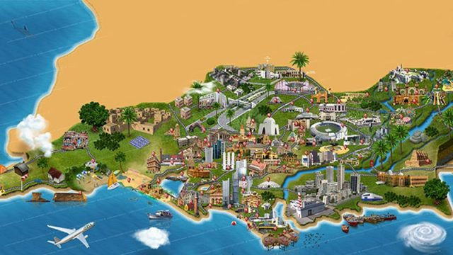

The validity is still alive, well and bright, Oh beloved Karachi, a marvellous sight.

May your loveliness long forever, May you be the land of peace ever!