 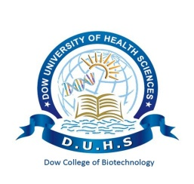

**DOW COLLEGE OF BIOTECHNOLOGY**

Rahaima Ahmed, Kissa Zehra, Muhammad Bilal, Farwa Naz, Laiba Azhar, Unzila Khan, Asna Noman, Sehrish Butt, Dr. Yahya Noori, Aliya Shujat

***“PLANT BASED NON-ALCOHOLIC PERFUME”***

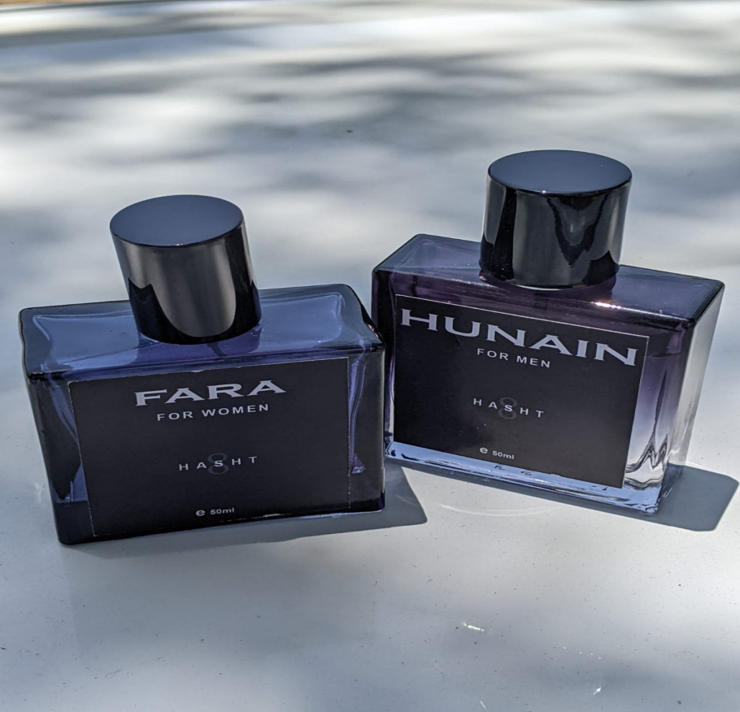

**INTRODUCTION:**

The enchanting art of perfumery in Pakistan is steeped in rich history, dating back centuries. In recent times, the perfume industry has experienced exponential growth, with a multitude of scents flooding the market. Yet, the industry in Pakistan faces various challenges in maintaining self-sustainability and creating unique fragrances. Traditional perfume production often relies on importing costly raw materials, causing a drain on the country's economy and depriving local artisans of creative autonomy. We present an innovative idea to revolutionize the perfume industry in Pakistan through the implementation of the Enfleurage method, enabling the production of oils and chemicals while ensuring self-sustainability. We can restore the industry's vitality by utilizing indigenous resources and reviving traditional techniques. Through meticulous refinement and adaptation, we can leverage Pakistan's abundant floral resources, such as jasmine, rosemary, sandalwood, and amber to produce exquisite essential oils. We aim to craft all-natural, alcohol-free perfumes, which align with the growing demand for eco-friendly and health-conscious products. The absence of alcohol eliminates the risk of skin irritation and ensures a longer-lasting fragrance experience. By blending essential oils with natural carriers and fixatives, we can offer consumers a unique olfactory journey while promoting sustainability and safeguarding their well-being. This gentle and sustainable process preserves the integrity of the flowers' aroma and provides a broader spectrum of scent profiles. The use of all-natural ingredients and the exclusion of alcohol not only cater to the discerning tastes of conscious consumers but also contribute to a greener and healthier future. The implementation of this proposal holds numerous benefits for Pakistan's perfume industry. It presents an extraordinary opportunity to foster self-sustainability, celebrate cultural heritage, and produce exceptional all-natural, alcohol-free perfumes.

**PROBLEM:**

Using chemical and alcoholic perfumes can pose several problems. Here are some common issues associated with them:

* Skin Irritation: Chemical perfumes often contain synthetic ingredients and harsh chemicals that can irritate sensitive skin. These chemicals can cause redness, itching, dryness, and even allergic reactions in some individuals.
* Respiratory Issues: Inhalation of chemical fragrances, particularly in enclosed spaces or when used in excessive amounts, can trigger respiratory problems such as asthma, allergies, or respiratory tract irritation. This is especially true for individuals who are already susceptible to respiratory issues.
* Environmental Impact: The production and disposal of chemical perfumes can have a negative impact on the environment. Many synthetic fragrances are derived from non-renewable resources and involve extensive chemical processes. When these perfumes are washed off and enter water systems, they can also contribute to water pollution.
* Longevity and Projection: Alcohol-based perfumes tend to have a high evaporation rate, resulting in shorter-lasting scents. The alcohol component can cause the fragrance to dissipate quickly, reducing its longevity and projection on the skin.
* Sensitivity and Allergies: Some individuals may be sensitive or allergic to certain chemicals or alcohol used in perfumes. This can lead to adverse reactions like skin rashes, headaches, dizziness, or nausea. People with fragrance allergies may find it challenging to find suitable perfumes that don't trigger their symptoms.
* Disruption of Natural Body Odor: Chemical perfumes can overpower or mask an individual's natural body odor. While this may be desirable for some, it can disrupt the natural balance of scent and potentially affect interpersonal communication and pheromone signals.
* Flammability: Alcohol, which is commonly used as a base for many perfumes, is highly flammable. This can pose a safety risk, especially when handling or storing perfumes near open flames or in areas with poor ventilation.
* To alleviate these problems, we opt for organic perfumes that use plant-based ingredients and essential oils instead of synthetic chemicals.

**SOLUTION:**

To address the concerns associated with chemical and alcoholic perfumes, we are introducing completely natural plant-based, non-alcoholic perfume, FARA and HUNAIN that can be an excellent alternative. Here are some solutions for creating such perfumes:

* Using Essential Oils: Essential oils extracted from plants provide a wide range of aromatic options for creating natural perfumes. They are derived from various plant parts such as flowers, leaves, bark, and seeds. We are using different essential oils like lavender, rosemary, jasmine, and sandalwood to develop unique fragrance combinations.
* Dilution with Carrier Oil: Essential oils are highly concentrated and potent, so they need to be diluted before application. Jojoba oil is being used to dilute essential oils while providing a suitable base for the perfume.
* Herbal Infusions: Apart from essential oils, we are using some of the herbal infusions to add depth and complexity to your perfumes. Dried herbs like witch hazel dissolved in carrier oil for a period of time. This will infuse the oil with the fragrance of the herbs, enhancing the overall scent of the perfume as well as reducing skin irritation and allergies.
* Using natural compounds: Considering natural and organic alternatives that use renewable resources and minimize harm to the environment. Thus, producing eco-friendly and sustainable perfumes.
* Longevity: Alcohol-based perfumes evaporate quickly, leading to shorter-lasting scents. So, we are launching plant based non-alcoholic perfume for longer-lasting fragrances.

**PRODUCT COST:**

Estimated Budget

|  |  |  |
| --- | --- | --- |
| INGREDIENTS | QUANTITY | COST |
| 1)Carrier Oil  2)Essential Oils  3)Witch Hazel | 1  Dozen  1 | 500  5000  1500 |
| BOTTLES(50 ml) |  |  |
| 1)Male Bottles  2)Female Bottles | 2  2 | 500  500 |
| OTHER COST |  |  |
| 1)Packaging | - | 2000 |
| 2)Local Advertising | - | 5000 |
| total |  | 15000 |

**Per Bottle Cost= 1000/- Rs**

**SUMMARY:**

The proposed revolution in the perfume industry in Pakistan aims to harness the Enfleurage method and the country's rich floral resources to create all-natural, alcohol-free perfumes. This innovative approach addresses the challenges of self-sustainability and creative autonomy while meeting the demands of conscious consumers. By embracing this change, Pakistan can reinvigorate its perfume industry, celebrate its cultural heritage, and contribute to a **greener** and **healthier** future by producing unique and environmentally friendly perfumes. This method allows for the extraction of delicate and complex scents without the need for harsh chemical solvents or alcohol, ensuring a more natural and sustainable fragrance creation process. The adoption of all-natural, alcohol-free perfumes in Pakistan’s perfume industry bring numerous benefits. Firstly, it aligns with the global shift towards sustainability and conscious consumerism, as more individuals are seeking products that are free from synthetic additives. This trend offers an opportunity for Pakistan to position itself as a leader in eco-friendly perfume production, attracting environmentally conscious customers both domestically and internationally. The country has a long history of producing exquisite fragrances and by embracing all-natural and traditional methods like Enfleurage, Pakistan can revive and celebrate its indigenous perfumery practices. This not only preserves the traditional art of fragrance-making but also showcases Pakistan's cultural richness to the world. By eliminating alcohol and synthetic chemicals from perfumes, Pakistan can reduce its ecological footprint and promote a healthier lifestyle. Alcohol-free perfumes are less likely to cause skin irritation and are generally safer for individuals with sensitivities or allergies and a longer-lasting fragrance experience is ensured. Moreover, the use of natural floral resources supports sustainable agriculture practices, encouraging the preservation of local ecosystems and the well-being of farmers and communities involved in the production process.

In summary, the shift towards all-natural, alcohol-free perfumes not only benefit the industry and consumers but also aligns with global trends towards sustainability. By choosing natural ingredients and adopting eco-friendly practices, Pakistan's perfume industry can position itself as a leader in sustainable perfumery, catering to a growing market of conscious consumers who prioritize both quality and environmental impact. By doing so, Pakistan can revitalize its perfume industry, celebrate its cultural heritage, and contribute to a greener and healthier future for all.

|  |  |
| --- | --- |
| INTERNAL FACTORS | |
| STRENGTHS + | WEAKNESSES – |
| * Healthy alternative for the people who are health conscious, sensitive to perfumes, smells and have skin allergies. * Provide a wide range of natural fragrances different from the alcoholic or other synthetic perfumes. * Sustainable and natural products are highly desirable among eco-conscious consumers. * Non-alcoholic, affordable. * Aromatherapy. | * Limited fragrances. * Extraction of essential oil is time consuming. * Intense competition. |
|  |  |
| EXTERNAL FACTORS | |
| OPPORTUNITIES + | THREATS – |
| * Due to the increasing demand for natural and organic products all over the world, our non-alcoholic plant based perfumes can gain the popularity and can achieve a larger market share. * Our perfumes have sustainability and natural organic factors; therefore we can collaborate and can do partnership with the familiar and well known cosmetic and beauty care brands to attract a wider customer range. | * The established and well-known brands can launch such perfumes which will be threatening for us as our market will decrease and the attention of customers will divert.(strong market competition). |
|  |  |