
Dow University of Health Sciences

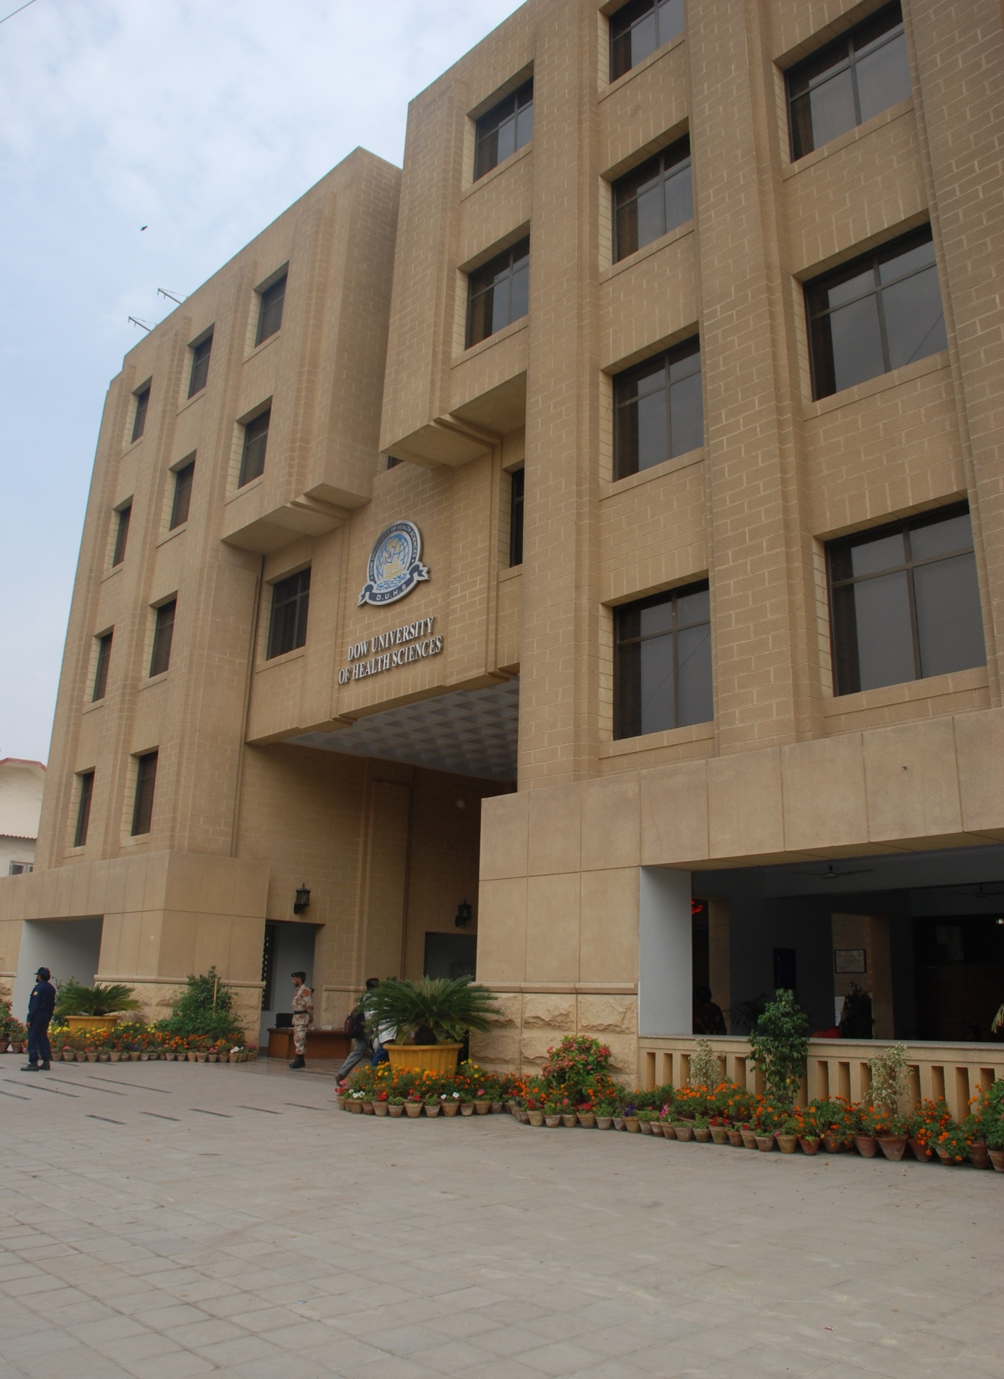



Foundation Module 01
Semester 1
First Year MBBS

Table of Contents

- Module Title. ----------------------------------------------------------------- 02

- Curricular organization of 5 years of MBBS. ---------------------------- 04

- Rationale. ---------------------------------------------------------------------- 05

- Terminal Objective. ----------------------------------------------------------- 05

- Enabling Objectives. ---------------------------------------------------------- 05

- Attendance Guidelines for the Academic Sessions. --------------------- 06

- Abbreviations used in the Weekly Schedules. --------------------------- 06

- Faculty Names --------------------------------------------------------------- 07

- Schedule of First Week. ------------------------------------------------------ 08

Curricular organization of 5 years of MBBS
Year | SEMESTER | MODULE I |  | MODULE II |  |  | MODULE III |  |  | MODULE IV
1 | I | Foundation and core  2wks |  | Cell and Cell Cycle  3wks |  |  | Blood , inflammation and immunity  3wks |  |  | Loco motor and Nerve, muscle  8wks
1 | II | Respiratory System  4wks |  | Cardiovascular System  4wks |  |  | Endocrinology  4wk |  |  | Neurosciences  4wks
2 | III | Head- Neck &Special senses  5 wks |  | GIT and liver  5 wks |  |  | Renal & Excretory System  4wks |  |  | Reproductive System  2wks
2 | IV | MICROBIOLOGY |  | GENERAL PATHOLOGY |  |  | GENERAL PHARMACOLOGY |  |  | Research Orientation and Methodology  Research Projects
2 |  | Community Health Sciences (CHS), Behavioral sciences (BS), Reproductive Health (RH), Ethics, Communication Skills, Clinical Skills
 |  | MODULE I | MODULE II |  |  | M ODULE III |  | MODULE IV |  |  | MODULE V
3 | V | Infectious Diseases  3 wks | CVS  3wks |  |  | Respiratory System  3 wks |  | GIT & liver  4 wks |  |  | Blood & Immunity  3 wks
3 | VI | CNS + Psychiatry  4 wks | Renal & excretory system  3 wks |  |  | Endocrinology  4 wks |  | Reproductive System  3 wks |  |  | Bone and Joints  2 wks
3 | VI | Forensic Medicine / Community Medicine  Clinical Rotations
4 | VII | Eye  ENT  Gynecology and Obstetrics  Dermatology/ psychiatry  Surgical sub specialties (2) |  |  |  |  | Eye  ENT  Gynecology and Obstetrics  Dermatology/ psychiatry  Surgical sub specialties' (2)
 | VIII | Eye / ENT  Gynecology and Obstetrics  Dermatology/ psychiatry  Surgical sub specialties' (2) |  |  |  |  | Eye / ENT  Gynecology and Obstetrics  Dermatology/ psychiatry  Surgical sub specialties' (2)
Community Health Sciences (CHS), Behavioral sciences (BS), Reproductive Health (RH), Ethics, Communication Skills, Clinical Skills
Clinical Rotations

 |  | MODULE I |  |  | MODULE II |  |  |  | MODULE III
5 | IX | Diagnostic Measures and Hospital Workings |  |  | 8:30 to 9:30 Lecture on problem based approach  Clinical Clerkship 9:30 to 2:30 (with Emergency, ambulatory, Intensive care)  - Medicine  - Surgery  - Pediatrics |  |  |  | 8:30 to 9:30 Lecture on problem based approach  Clinical Clerkship 9:30 to 2:30 (with Emergency)  - Medicine  - Surgery  - Pediatrics
5 | X | Communication Skills  Writing and Presenting Skills  Article Writing |  |  | 8:30 to 9:30 Lecture on problem based  approach  Clinical Clerkship 9:30 to 2:30 (with  Emergency, ambulatory, Intensive care)  - Medicine  - Surgery  - Pediatrics |  |  |  | 8:30 to 9:30 Lecture on problem based approach  Clinical Clerkship 9:30 to 2:30 (with Emergency)  - Medicine  - Surgery  - Pediatrics

Rationale: A Student stepping into a medical school requires orientation, introduction to medical sciences with respect to health & disease. A student also needs certain guidelines to achieve goals to become a successful but ethical doctor in future.
Terminal Objective: Foundation core module gives integration of basic concepts with their clinical application in life. It is devoted to the core concepts that underlie the foundation of basic sciences and their use in clinical medicine.
Enabling Objectives: At the end of Module students would be able to:
- Get them oriented to the college environment, Departments, Faculty, registration system, and their mentors.
- Identify different basic sciences, their integration and application for understanding structure and function of human body.
- Recognize the importance of COMMUNITY MEDICINE & BEHAVIORAL SCIENCES
- Conceptualize the integrated assembly of structures and functions in human body by relating with the arrangement of different LEVELS OF ORGANIZATION
- Define ANATOMY , differentiate between its various BRANCHES and state their practical application in different fields of medicine
- Recognize the importance of PHYSIOLOGY in modern medicine
- Define BIOCHEMISTRY and recognize its importance and application in medical practice.
- Identify the different types, occurrence and role of macromolecules for the healthy living of human beings.
- Recognize the exact location of a dissected/prosected part /organ of human body with respect to various TERMS of POSITIONS, DIRECTION, and BODY PLANES.
- Interpret the movements of different parts of human body by applying the knowledge of various TERMS of MOVEMENT.
- Differentiate between ventral and dorsal BODY CAVITIES with localization of organs and viscera and locate those viscera by recalling ABDOMINO PELVIC QUADRANTS.
- Classify PROTIENS on the basis of structure, function and chemical reactions and recognize their importance in balanced diet and health.
- Appreciate the function of Support and Protection by using the general knowledge of SKIN, FASCIA and BONES.
- Use the knowledge of CARBOHYDRATE chemistry for health.
- Associate the Movement and Posture of human body with the GENERAL ANATOMY OF MUSCLES and JOINTS.
- Justify the importance of LIPIDS for balanced diet and health.
- Explain the Physiological functions of Transportation and Exchange by applying knowledge of the GENERAL ANATOMY OF BLOOD VESSELS.
- Integrate the function of Defense with the GENERAL ANATOMY OF LYMPH NODES AND LYMPHATICS.
- Functional organization of human body and fluid compartments.
- Recognize the role of physiochemical aspects for the maintenance of homeostasis.
- Recognize the importance of nucleic acid structure and function with metabolism, protein synthesis and Genetics.
- Classify vitamins and minerals; recognize their main sources in diet, assimilation in human body with related functions and abnormalities.
- Orientate with the processes of metabolism, enzymes and coenzymes in clinical diagnosis.
- Justify the functions of Control and Regulation with the knowledge of arrangement and Distribution of NERVOUS SYSTEM.
- Get introduced to the regulatory mechanism of body by applying the knowledge of endocrine system.
- Apply the rules of laboratory use during visits to Diagnostic Labs.

Attendance Guidelines for the Academic Sessions:
Please note that following guidelines will be strictly observed during the academic years 2009-2010.
Case Based Learning (CBL) Session:
All the CBL sessions are mandatory. Missing any CBL session may result in failure in the module
(CBL Sessions will commence in the second module of cell & cell cycle)
Practicals and Tutorials.
All Practical and Tutorials are mandatory
All skill based sessions will be signed off
They will constitute one of the eligibility criterions for professional examination
Materials from these sessions will be included in the module practical examination (details of which will be communicated later) and semester examination.
Clinical Skills: Clinical skills sessions are mandatory and have to be signed off. Eligibility to appear in the OSCE and OSPE will be based on satisfactory signing off on all the clinical skills.
Longitudinal themes (Ethics, Communication Skills and Behavioral Sciences): All the sessions are mandatory and have to be signed off. For any missed session, satisfactory submission of assignment will be required.
If the requirement of 90% attendance is not fulfilled by any student, he/ she would not be allowed to appear in the Module/ Semester Examination.
Abbreviations used in the Weekly Schedules:
 | DUHS | Dow University of Health Sciences
 | DMC | Dow Medical College
 | DIMC | Dow International Medical College
 | SMC | Sindh Medical College
 | CBL | Case Based Learning
 | OSCE/OSPE | Objective Structure Clinical Examination/ Objective Structure Practical Examination
 | BCQ’s | Best Choice Question
 | Lec | Lectures
 | DDRL | Dow Diagnostics Research Lab
 | Prac | Practical
 | Disc | Discussion
 | Tut | Tutorial
 | M A | Moin Auditorium
 | ALH | Anatomy Lecture Hall
 | ADH | Anatomy Dissection Hall
 | AM | Anatomy Museum Hall
 | BL | Biochemistry Lab
 | PL | Physiology Lab
Faculty Names of DMC:

Anatomy Department DMC Physiology Department DMC
Professor Muhammad Zia Iqbal Dr. Masroor H. S. Bukhari
Professor Muhammad Ilyas Dr. Muhammad Shakil
Dr. Imtiaz Ali Wagan Dr. Perveen Qader
Dr. Naheed Khan Mrs. Neelofer Sultana
Dr. Muhammad Javed Anjum Dr. Ambreen Shaikh
Dr. Farrukh Mustafa Dr. Nafees Khalid
Dr. Riaz Hussain Unar Dr. Maria Ansar
Dr. Sofia Tabbasum Dr. Muhammad Anwar
Dr. Mohni Bai
Dr. Ghulam Mujtaba
Dr. Shahid Pervez Shaikh
Dr. Amanullah Mangi

Biochemistry Department DMC. Forensic Medicine Department DMC
Professor Shamim A. Siddiqui. Professor M. Umar Memon
Dr. Nadeem Alam Dr. Farhat Hussanin Mirza
Dr. Rukhsana Rubeen Dr. Abdul Ghaffar
Mrs. Mumtaz Naeem Dr. Musarat Sultana
Dr. Tehseen Iqbal Dr. Partab.
Dr. Zia Ikramuddin
Dr. Mehwish Ikram
Dr.Syed Danish Hassan

Pathology Department DMC
Professor Asif Bhurgri
Professor Kartar Dawani
Dr. Yasmeen Taj
Dr. Capt. Muhammad Saeed
Dr. Aftab Ahmed Soomro

Dr. Imtiaz Hussain
Dr. Izhar Fatima
Dr. Karam Ali Mirjat
Dr.Dr.Ikramullah Bhurgery
Dr. Faaez Ahmed Agha
Dr. Javed A. Badvi

Pharmacology Department DMC
Dr. Syed Saud Hasan
Dr. Naseemullah Siddiqui
Dr. Sahikh Nadeem
Dr. Mahay Rookh Asif
Dr. Tafazzul Hussain
Dr. Fuad Shaikh
Dr. Shamaila Khalid
Dr. Qamar Uzzaman

Community Medicine Department DMC
Dr. Capt. Meher F. Hansotia
Dr. Yasmeen Mumtaz
Dr. Muhammad Idress
Dr. Syed M. Ashraf Jahangir
Dr. Munawar Hassan
Dr. Tajuddin Malik
Dr. Syed Anzar Ahmed Rizvi
Dr. Mehar Alam
Dr. Lubna Raza
Dr. Nighat Mirza
Dr. Farzana Qureshi
Dr. Capt. Abdul Rahim
Dr. Muneer Ahmed Shaikh
Dr. Sameera Mahar
Dr. Rauf Shaikh
Mr. Mohsin Iqbal
Dr.Vinod Kumar

Weekly Schedule Foundation Module:
Time Table: First Week 16-21 November, 2009

 | 8:30- 9:30 | 9:30-10:30 |  |  |  | 11:00-12:45 |  |  | 1:15-3:00
Mon  DAY 1  VENUE | Welcome address and  Introduction to faculty and Mentor system  PROF  JUNAID ASHRAF  (MA) | Introduction to the faculty of Physiology  Importance of Physiology in modern medicine  PROF. MASROOR BUKHARI  (MA) |  |  |  | 11:00 – 12:00 | 12:00 -12:45 |  | Introduction to Mentor System  DR. ABDUL WAHID USMANI  (MA)
 |  |  |  |  |  | Introduction to the Faculty of Anatomy,  Seven Levels of organization &  Introduction of various  systems of the body  PROF.ZIA IQBAL  (MA) | Introduction to the Faculty of Biochemistry  Biochemistry and its role, importance and application for medical purpose  PROF. SHAMIM SIDDIQUI  (MA) |  | Introduction to Mentor System  DR. ABDUL WAHID USMANI  (MA)
Tue  DAY 2  VENUE | Biochemistry  Role of macromolecules for the healthy living of human beings.  PROF.SHAMIM  (MA) | Anatomy and its branches, terminologies  DR.IMTIAZ WAGGAN  (MA) |  |  |  | Biochemistry  Basic concepts of chemistry in relation to maintenance of healthy life and diagnosis and management of disorders (Clinical lab Investigations)  DR.NADEEM ALAM  (MA) |  |  | Community Medicine.  Introduction to public health in community DR.YASMEEN MUMTAZ  (MA)
Wed  DAY 3  VENUE | Anatomy,  TERMS of POSITIONS, DIRECTION, and BODY PLANES  PROF.ILYAS  (MA) | Biochemistry  Proteins and its classification  DR.NADEEM ALAM  (MA) |  |  |  | Mentor Meeting  With respective Mentors  (IN THEIR RESPECTIVE DEPARTMENTS) |  |  | Gp 1- Anatomy Discussion: Terms of movement. (standardized person)  DR.SHAHID  (ALH)  Gp 2- Practical/ Tutorial: Protein structure and Function  DR.NADEEM ALAM  (BL)  Gp 3- Self study: of Anatomy Models in Museum  DR.MOHNI &  DR.SOOFIA  (A. M)
Thurs  Day  4  VENUE | Anatomy  Ventral and dorsal BODY CAVITIES with localization of organs and viscera and locate those viscera by recalling ABDOMINO PELVIC QUADRANTS.  DR.IMTIAZ WAGGAN  (M. A) |  |  |  |  | Gp 2- Anatomy Discussion Terms of movement. (standardized person)  DR.SHAHID (ALH)  Gp 3- Practical/ Tutorial: Protein structure and Function  DR.NADEEM ALAM (B L)  Gp 1- Self study: of Anatomy Models in Museum  DR.MOHNI & DR.SOOFIA (A.M) |  |  | Behavioral sciences  Behavioral sciences and its importance in medical practice  DR.QAZI IRSHAD  (MA)
Fri  Day 5  VENUE | Biochemistry  Definition, classification and clinical importance of carbohydrates..  DR.NADEEM ALAM  (MA) |  | Anatomy  General anatomy of Skin, its appendages, superficial and deep fascia  PROF.ZIA IQBAL  (MA) | 10:30 – 12:00  Gp 3- Anatomy Discussion: Terms of  Movement (standardized person)  DR.SHAHID (ALH)  Gp 1- Practical/ Tutorial: Protein structure  And Function DR.NADEEM ALAM (B L)  Gp 2- Self study: of Anatomy Models in  Museum DR.MOHNI & DR.SOOFIA (A. M).
Sat  Day 6  VENUE | Biochemistry  Structure of glucose and glycogen  DR.NADEEM ALAM  (MA) |  | Anatomy  Classification, function and development of bones and Cartilages  DR.IMTIAZ WAGGAN  (MA) |  | D.D.R.R.L  Rules of laboratory use during visits of Diagnostic Labs  (MA) |  |  |  | Anatomy Discussion  Parts of adult and young long bones, blood supply of bones and radiographs of young and adult long bones  PROF.ILYAS  (MA)

DMC 2nd Week
Time Table: Second Week:

 | 8:30- 9:30 | 9:30-10:30 |  | 11:00-12:45 |  | 1:15-3:00
Mon  Day 7  23-11-09  VENUE | Biochemistry  Definition and classification of Lipids  PROF.SHAMIM  (MA) | Anatomy  Joints ,classification  ( according to structure, functions, movement)  factors affecting their stability,  DR.IMTIAZ WAGGAN  (MA) |  | Biochemistry practical: Importance of Protein detection and estimation in clinical disorders (Gp:1) ( DR. MUMTAZ) (BL)  Biochemistry Tutorial: Nutritional Importance of CHO & LIPIDS (Gp:2)  ( DR. ZIA) (New Building, Hall 203) Presentations by students  Why you opted for MEDICINE? (Gp 3)  DR.IMTIAZ WAGGAN (ALH) |  | Interactive Discussion  Biochemistry: Why and how Vitamins are necessary?  Introduction, Sources and functions, Deficiency excess of Vitamins  IN THREE GROUPS  - DR.NADEEM ALAM (MA)  - DR. TAHSEEN (ALH)  - DR. MUMTAZ ((New Building, Hall 203 )
Tues  Day 8  24-11-09  VENUE | Anatomy  Muscles types, parts, Motor Unit classification (acc.  To fiber arrangement, actions)  PROF.ZIA IQBAL  (MA) | Biochemistry  Functional organization of human body and fluid compartments  DR.NADEEM ALAM  (MA) |  | Biochemistry practical: Importance of Protein detection and estimation in clinical disorders (Gp 3( DR. MUMTAZ) (BL)  Biochemistry Tutorial: Nutritional Importance of CHO & LIPIDS(Gp:1)  (DR. ZIA) (New Building, Hall 203 )  Presentations by students  Why you opted for MEDICINE? (Gp2)  ROF.ILYAS (ALH) |  | Anatomy Discussion on models: Bones: Gp 1  DR. AMANULLAH MANGI (A M)  Anatomy Discussion on models: Muscles: Gp 2  DR.SOOFIA (ALH)  Anatomy Discussion on models: Joint: Gp 3  DR.MOHNI (ADH)
Wed  Day 9  25-11-09  VENUE | Physiology  Homeostasis: Role of different body systems to maintain the constancy of internal environment  DR.MASROOR BUKHARI  (MA) | Anatomy  GENERAL ANATOMY OF BLOOD VESSELS  ROF.ILYAS  (MA) |  | Biochemistry practical: Importance of Protein detection and estimation in clinical disorders (Gp:2)  (DR. MUMTAZ) (BL)  Biochemistry Tutorial: Nutritional Importance of CHO& lipids (Gp:3)  (DR. ZIA) (New Building, Hall 203 )  Presentations by students  Why you opted for MEDICINE? (Gp 1)  P PROF.ZIA IQBAL (ALH)
Thus  Day 10  26-11-09  VENUE | Anatomy  GENERAL ANATOMY OF LYMPH NODES AND LYMPHATICS  PROF.ZIA IQBAL  (MA) | Physiology  Role of control systems in regulating the body functions  Characteristics of control system, -ve , +ve feedback  DR.PERVEEN QADIR  (MA) |  | Anatomy Discussion on models:  Bones: Gp 2 DR. AMANULLAH MANGI (AM)  Anatomy Discussion on models:  Muscles: Gp 3 DR.SOOFIA (ALH)  Anatomy Discussion on models:  Joint: Gp 1 DR.MOHNI (ADH) |  | Interactive Discussion  Biochemistry: Why and how minerals are important for health?  Introduction, Sources functions, Deficiency and excess of minerals  - DR.NADEEM ALAM (MA)  - DR. TAHSEEN (ALH)  - DR. MUMTAZ (BL)
EID HOLIDAYS
Tuesday  Day 11  01-12-09  VENUE | Physiology  Introduction to  endocrine system  DR.ATIF  (MA) | Biochemistry  Physiochemical aspects:  H2O, Adsorption, Viscosity, Osmosis etc  DR.ZIA/ DR.TEHSEEN  (MA) |  | Anatomy  General organization of Nervous system.  Introduction to CNS and PNS  PROF.ILYAS  (MA) |  | Anatomy Discussion on  models: Bones: Gp 3  DR. AMANULLAHMANGI (A M)  Anatomy Discussion on models:  Muscles: Gp 1  DR.SOOFIA (ALH)  Anatomy Discussion on models: Joint: Gp 2  DR.MOHNI (ADH)
Wednesday  Day 12  02-12-09  VENUE | Biochemistry  Introduction and chemical Structure of nucleotide and nucleic acids  .DR.NADEEM (MA) | Anatomy  Introduction to A.N.S  PROF.ZIA IQBAL  (MA) |  | Mentor Meeting  With respective Mentors  (IN THEIR RESPECTIVE DEPARTMENTS) |  | Biochemistry Tutorial: Importance of Metabolisms, and enzymes and coenzymes in clinical diagnosis,  (three Batches)  - DR.NADEEM ALAM (MA)  - DR. TAHSEEN (ALH)  - DR. MUMTAZ (BL)

